  - Business Research and Innovation Initiative
  - Fact sheet

Alternative packaging for premium Australian wine
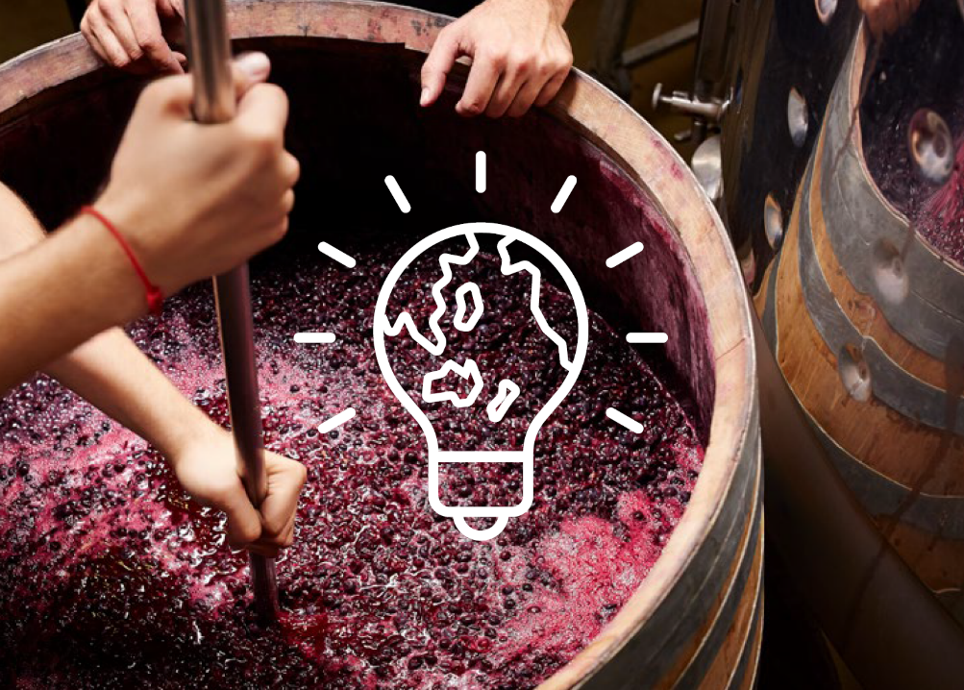
Wine Australia is seeking innovative solutions to increase the sustainability of the wine sector.

Opportunities
- Access grant funding of up to $1.1million
- Work with government
- Keep ownership of all IP developed for the project
- Accelerate commercial opportunities
- Potential for procurement
- Receive industry expertise and guidance
- Contribute to Australia’s Net Zero targets

The challenge
Can you reduce the carbon footprint of Australia’s wine packaging?
This challenge aims to reduce the carbon footprint of wine packaging to support the sector’s net zero commitment. It must also maintain in‑bottle ageing properties and consumers’ quality perception.
Manufacturing of wine packaging and transport of packaged wine accounted for around 70% of the carbon emitted by the wine industry in 2020-21. There are many reasons for this, but heavy glass bottles are the main cause.
Transitioning to sustainable packaging is not without its challenges.
Innovative wine packaging such as lighter glass bottles, bag-in-box, aluminium cans and PET plastic all produce lower emissions. However, they are mainly used for non‑premium wines because consumers associate traditional glass packaging with wine quality.
Unfortunately, PET suffers from limited shelf-life as it is not stable beyond 12 months because of oxygen permeability and aroma absorption from the material. Many of the alternatives to glass also have limited recyclability in household systems.
Despite the issues, Wine Australia still sees potential to revolutionise premium wine packaging. Lower-carbon, easily-recyclable packaging could not only cut wine sector emissions, but also be applied to other food and beverage industries, or other sectors.
Wine Australia has several initiatives to support grape and wine producers to reduce emissions and support sustainability, while maintaining market access. These include the Environmental, Social, and Governance (ESG) Investment Plan and an Emissions Reduction Roadmap for the Australian grape and wine sector. These documents may prove to be useful resources for applicants.
The Australian grape and wine sector aims to be net zero. Adopting sustainable packaging is critical to achieving this.

Potential themes
Solutions could consider:
- low or zero-carbon packaging materials
- food science
- branding and marketing
- sustainable transport
- material innovation
- design
- environmental impact mitigation
- food and beverage impact
- circular economy and waste reduction
- wine ageing
- product shelf life
- consumer education and behaviour.

Solution requirements
Wine Australia is open to a range of solutions to help address this challenge. Solutions must give a sustainable and practical alternative to glass packaging for premium Australian wine. They should address the challenges of shelf‑life stability, durability, consumer perceptions and cost.
BRII is seeking new-to-world solutions. The focus of this challenge is wine packaging. Solutions could also consider other emissions-heavy parts of the sector, such as transport.

Solutions:
- must reduce greenhouse gas emissions for the sector and reduce waste
- should be versatile and able to be used across different wine types and packaging sizes
- should have the potential to be adopted across wine production, both in Australia and around the world
- must also work with existing manufacturing and recycling infrastructure
- could look at increasing manufacturing efficiency as a way to reduce carbon emissions
- could consider potential use in other food and beverage or unrelated sectors to increase commercialisation opportunities.
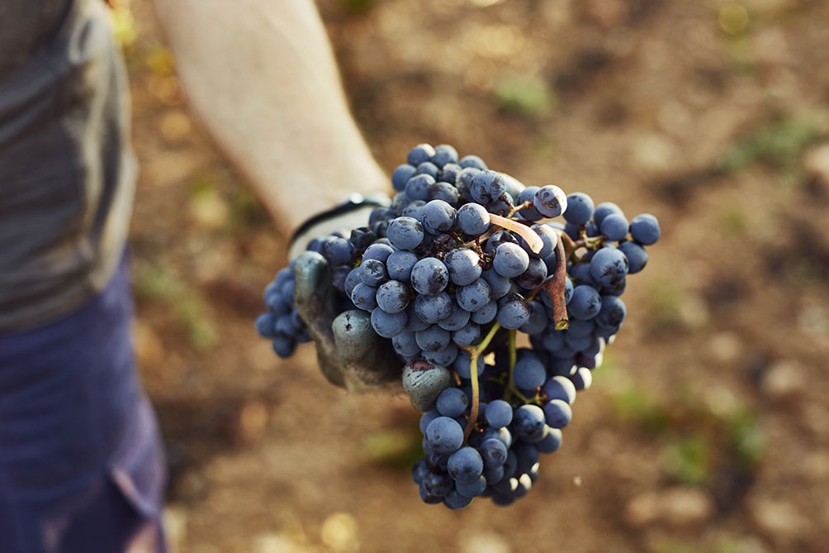

Solution benefits
Proposed solutions should have the potential to be used commercially across Australia’s wine industry, but also other industries and internationally. Applicants will keep their intellectual property (IP), so commercial application possibilities for new technologies are considerable.
Innovations can lead to commercial benefits for wine manufacturers and have wider commercial benefits for applicants.
Solutions that reduce the carbon footprint of the wine sector will benefit the environment. Those solutions that improve time efficiency may support the sector to increase productivity and revenue.
There is a growing market for sustainably-sourced products. Reducing carbon emissions can help safeguard the future of Australian wine.

How to apply
Have you got a great idea to solve this challenge?
For more information or details on how to apply, visit business.gov.au/BRII-RLE or call 13 28 46.

