**Customer**: Likely Theory

Likely Theory’s innovative product, Converlens, enables governments to collect, analyse and report data while they are undertaking consultations.

**Employees:** a team of six experienced entrepreneurs, engineers, psychologists and policy officers.

**Sector**: Technology

**Location**: Doubleview, WA

**Electorate:** Curtin

**Products / Industries of the electorate**:

Industries include medical, education, retail, recreation, light industrial, professional services, commercial, and hospitality.

**Program**: Business Research and Innovation Initiative

The Business Research and Innovation Initiative (BRII) provides small to medium sized enterprises with grant funding to develop innovative solutions for government policy and service delivery challenges.

**Funding**: Likely Theory received grant funding from BRII to develop the Converlens artificial intelligence based software.

For more information on **Likely Theory** visit [www.converlens.com](http://www.converlens.com).

For more information on the **Business Research and Innovation Initiative** visit [business.gov.au](https://www.business.gov.au/assistance/business-research-and-innovation-initiative) or call 13 28 46.

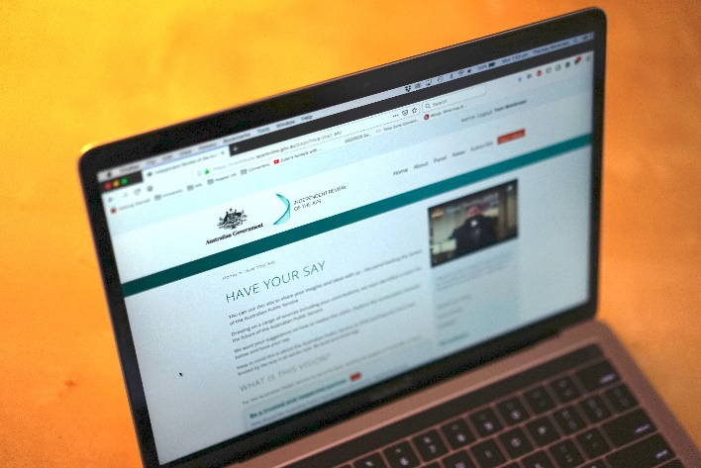

Converlens is Likely Theory’s web-based consultation platform. It enables better engagement and consultation with communities and within departments. Converlens utilises artificial intelligence (AI) technology to process complex qualitative data.

Converlens provides rapid analysis and deep insights from a range of sources - including written, verbal and social media.

The benefit for users is an easy-to-use platform that enables people to participate, contribute and collaborate on a broader scale than before.

Converlens can be utilised for internal consultation, offering rapid formation of project spaces where people can ideate, create, share and edit content. It can capture comments and feedback.

Understanding internal engagement, pulse checks on employee sentiment and deep dives on organisation culture can be facilitated and analysed on Converlens, providing an easy to use, end-to-end solution for internal consultation.

**“The high level of stakeholder access and support offered throughout BRII has helped inform our product development and ultimately led to our commercial success.” Tom Workman, Director,** **Likely Theory**