R&D Tax Incentive

Guide to Interpretation
  - A guide to help you assess whether your R&D is eligible for the R&D Tax Incentive
May 2024
| business.gov.au/rdti

Copyright
© Commonwealth of Australia 2024
Ownership of intellectual property rights
Unless otherwise noted, copyright (and any other intellectual property rights, if any) in this publication is owned by the Commonwealth of Australia.
Creative Commons Attribution 4.0 International Licence CC BY 4.0
All material in this publication is licensed under a Creative Commons Attribution 4.0 International Licence, with the exception of:
- the Commonwealth Coat of Arms
- content supplied by third parties
- logos
- any material protected by trademark or otherwise noted in this publication.
Creative Commons Attribution 4.0 International Licence is a standard form licence agreement that allows you to copy, distribute, transmit and adapt this publication provided you attribute the work. A summary of the licence terms is available from https://creativecommons.org/licenses/by/4.0/. The full licence terms are available from https://creativecommons.org/licenses/by/4.0/legalcode.
Content contained herein should be attributed as R&D Tax Incentive Guide to Interpretation, Australian Government Department of Industry, Science and Resources.

Disclaimer
The Commonwealth as represented by the Department of Industry, Science and Resources has exercised due care and skill in the preparation and compilation of the information in this publication.
The Commonwealth does not guarantee the accuracy, reliability or completeness of the information contained in this publication. Interested parties should make their own independent inquires and obtain their own independent professional advice prior to relying on, or making any decisions in relation to, the information provided in this publication.
The Commonwealth accepts no responsibility or liability for any damage, loss or expense incurred as a result of the reliance on information contained in this publication. This publication does not indicate commitment by the Commonwealth to a particular course of action.

Contents
Guide to Interpretation i
Overview 2
What is the R&D Tax Incentive? 2
How do you apply? 2
Registration and review 2
Why should you read this guide? 3
How do you navigate this guide? 3
Where to get help 4
Self-assessment 5
Q1: Am I an eligible R&D entity? 5
Q2: Are my activities eligible for the R&D Tax Incentive? 6
Q3: Are any of my activities covered by a determination? 6
Q4: Is my R&D expenditure eligible? 7
Q5: Do I have evidence to support my claim? 7
Self-assessment tool 8
Eligible R&D activities 9
Projects and R&D activities 11
Core R&D activities 12
Are my activities core R&D activities? 18
Exclusions 19
Supporting R&D activities 28
Dominant purpose 29
Evidence 31
What happens if we review your registration? 31
Records to show eligibility 33
Other guides 35
List of guides 35

Acknowledgement of Country
Our department recognises the First Peoples of this Nation and their ongoing cultural and spiritual connections to the lands, waters, seas, skies, and communities.

We Acknowledge First Nations Peoples as the Traditional Custodians and Lore Keepers of the oldest living culture and pay respects to their Elders past and present. We extend that respect to all First Nations Peoples.

Overview

What is the R&D Tax Incentive?
The R&D Tax Incentive (R&DTI) encourages business to conduct research and development activities that generate new knowledge likely to benefit the wider Australian economy. It aims to boost competitiveness and improve productivity across the Australian economy by:
- encouraging industry to conduct R&D that may not otherwise have been conducted
- offering a greater incentive for smaller firms to undertake R&D
- providing business with broad-based, market-driven support that is open to all industry sectors
- help with accessing reliable research services.
R&D drives innovation that leads to productivity improvements and economic growth. The R&D Tax Incentive is the government’s key mechanism to stimulate industry investment in R&D in Australia.
The Department of Industry, Science and Resources (the department), on behalf of Industry Innovation and Science Australia (IISA), jointly administers the R&D Tax Incentive with the Australian Taxation Office (ATO). The R&DTI is a targeted tax offset program.
You need to be an eligible R&D entity to apply to register for the R&DTI. A refundable tax offset is available for R&D entities with an annual aggregated turnover under $20 million. A non-refundable tax offset is available to R&D entities with an annual turnover of more than $20 million.
These tax offsets are only for core R&D and supporting R&D activities (eligible R&D activities) which are defined in sections 355–25 and 355–30 of the Income Tax Assessment Act 1997 (ITAA 1997). Your activities must meet all of the requirements of the legislation to be eligible for the program.
You need to have eligible R&D expenditure of $20,000 or more to claim the tax offset. The only exception to this is if you incur R&D expenses to a registered Research Service Provider (RSP) or a Cooperative Research Centre (CRC). You can only claim for eligible R&D notional deductions, which includes expenditure and decline in value amounts. The ATO has guides on eligible expenditure.
The R&DTI supports eligible R&D activities you conduct in Australia. It may also support eligible R&D activities you conduct overseas. You must apply for and receive an Overseas Finding before you can claim for expenditure on overseas R&D activities.
You can also apply for an Advance Finding if you want to know if your R&D activities are eligible.

How do you apply?
You need to register with us before you can claim for expenditure on eligible R&D activities through the ATO. You need to apply to register within 10 months of the end of the income year in which you conduct your activities. We will issue you with a registration number. You will need to enter this number in the R&D Tax Incentive schedule in your annual income tax return.
You are responsible for assessing whether you meet all legal requirements before you register for the R&DTI, even if you seek professional advice. Registering with us does not mean your activities are eligible. They remain subject to review.

Registration and review
While the R&DTI is a self-assessment program, we may review your registration. If we do, we will assess whether the activities you describe meet the definitions in s 355–25 and s 355–30 of the ITAA 1997. We may find some of your activities eligible and others not.
We will work with you to understand your activities when we assess or review your activities. Our guides will help you assess the activities you conduct or plan to conduct and register. However, our guides provide general guidance only. You need to refer to the legislation when you assess whether your activities are eligible.
The ATO may review your R&DTI claim. If they do, they will expect to see evidence that your R&D expenditure is only on eligible R&D activities. The department and the ATO work closely together to administer the R&DTI. Either agency may ask the other agency to conduct a review.

Why should you read this guide?
This guide will help you assess if your R&D is eligible for the R&D Tax Incentive. The content in this guide reflects the way we apply the legislation. This is informed where applicable by decisions from the Administrative Appeals Tribunal (AAT) and the Federal Court of Australia (FCA). This guide will help you answer five questions:
Q1: Am I an eligible R&D entity?
Section 355–35 of the ITAA 1997 defines the term R&D entity. Only R&D entities can apply to register for the R&DTI.
Q2: Are my activities eligible for the R&D Tax Incentive?
The R&DTI allows a tax offset for eligible R&D activities. You need to assess whether activities in your R&D project are eligible and this is the focus of this guide.
Q3: Are any of my eligible R&D activities covered by a determination?
You may be able to use the clinical trials determination which provides that certain clinical trial activities will be core R&D activities under the R&DTI. Determinations are generally binding on the department.
Q4: Is my R&D expenditure eligible?
You must register with us for the R&DTI before you can lodge a claim with the ATO to receive a tax offset for eligible R&D expenditure. The ATO has detailed guidance on eligible expenditure.
Q5: Do I have evidence to support my claim?
We expect you to keep evidence of all activities that you register or plan to register for the R&DTI. Record keeping is a key part of managing your business and R&D.

How do you navigate this guide?
Each part of this guide covers an aspect of the program. We refer to the relevant sections of the ITAA 1997 and explain the key terms in these sections. When we quote from the legislation we provide the section reference.
We provide hyperlinks to:
- key terms, which appear later in this guide
- our website, the ATO or other organisations.
This guide also has visual tools, which include a self-assessment tool to help you assess if you are eligible to register and claim for the R&DTI.
Throughout this guide we use the term ‘eligible’ to mean entities, activities or expenditure that meet the legislative requirements of the R&DTI.

Where to get help
We know from experience that the more information and support you have, the more likely you are to register activities that are eligible for the R&DTI. We are here to support you.
For more about the R&D Tax Incentive
- Visit business.gov.au – Research and Development Tax Incentive
- Contact us on 13 28 46
- Attend one of our information sessions, register at business.gov.au - R&D Tax Incentive events and information sessions
- See Part III of the Industry Research and Development Act 1986
- read Division 355 in the Income Tax Assessment Act 1997
- You can also read about decisions from the AAT and FCA on our website visit business.gov.au - External review of R&D Tax Incentive decisions

Self-assessment
Under the R&DTI, you first need to assess whether you are eligible to register as an R&D entity. Next you assess if your activities are eligible. Further, you assess whether the expenditure on your R&D activities in an income year is eligible. We expect you to keep evidence to support your claim.
The questions in this section will help you assess whether you are eligible to register for and claim the R&DTI. We explain these concepts in later sections.

Q1: Am I an eligible R&D entity?
Only R&D entities can register for the R&DTI. The term R&D entity is defined in section 355–35 of the ITAA 1997:
R&D entities
- Each of the following is an R&D entity:
  - a body corporate incorporated under an Australian law
  - a body corporate incorporated under a foreign law that is an Australian resident.
- A body corporate incorporated under a foreign law that:
  - is a resident of a foreign country for the purposes of an agreement in force between that country and Australia that:
    - Is a double tax agreement (as defined in Part X of the Income Tax Assessment Act 1936); and
    - Includes a definition of permanent establishment; and
  - carries on a business in Australia through a permanent establishment (within the meaning of that definition) of the body corporate in Australia;
is an R&D entity to the extent that it carries on business through that permanent establishment.
- However, an exempt entity cannot be an R&D entity.

You are an R&D entity if you lodge your tax return as an Australian resident company. You may also be an R&D entity in other limited situations.
You are not eligible for the R&DTI if you are:
- an individual including a sole trader
- a corporate limited partnership
- an exempt entity (where your income is exempt from income tax) for example a not for profit organisation or a university
- a trust (other than a public trading trust with a corporate trustee)
For more about R&D entities visit ato.gov.au – Research and Development Tax Incentive

Q2: Are my activities eligible for the R&D Tax Incentive?
The R&DTI provides a tax incentive for eligible R&D activities. You need to assess whether activities within your R&D project are eligible, and this is the focus of this guide.
To register eligible R&D activities, you need to conduct or plan to conduct at least one core R&D activity. Some activities are excluded from being core R&D activities. Your supporting R&D activities must be directly related to at least one of your core R&D activities. You must specify your activities when you register them for the tax offset.
Eligible R&D activities may span more than one income year. If you conduct part of a core R&D activity in an income year, also explain when and how you will conduct the future parts of your activity.
To be eligible, you must:
- conduct or plan to conduct at least one core R&D activity
- register your core R&D activities
- only register supporting R&D activities that are directly related to at least one of your core R&D activities (and, in some cases, that you conduct for the dominant purpose of supporting at least one of your core R&D activities).
For more about the R&D Tax Incentive
- Visit business.gov.au – Research and Development Tax Incentive
- Contact us on 13 28 46

Q3: Are any of my activities covered by a determination?
R&D Tax Incentive determinations set out how the department, on behalf of IISA, will exercise powers and perform duties to administer the R&D Tax Incentive. They cover positions the department must take when interpreting and applying the law for certain circumstances.
Industry Research and Development (Clinical Trials) Determination 2022 is the first determination for the program.
This determination sets out that certain clinical trials are core R&D activities for the purpose of the R&D Tax Incentive. You may be able to rely on the clinical trials determination when you register your clinical trial as a core R&D activity under the R&D Tax Incentive if:
- it is a phase 0, I, II, III, pre-market pilot stage, or pre-market pivotal stage clinical trial for an unapproved therapeutic good
- it is registered with the Therapeutic Goods Administration (TGA) under the Clinical Trials Approval (CTA) or Clinical Trials Notification (CTN) schemes.
For more information, please read the clinical trials determination guide. This guide includes information about how to respond to questions in the customer portal. It also includes a link to the determination on the Federal Register of Legislation.
For more about R&DTI determinations visit business.gov.au - R&DTI Determinations

Q4: Is my R&D expenditure eligible?
You need to register your R&D activities with us each year before you can lodge a claim with the ATO for eligible R&D expenditure. When you register for the R&DTI with us, you will receive a number that you will need to quote to lodge a claim with the ATO.
Your eligible R&D expenditure for the income year must be greater than $20,000 to claim the R&DTI (unless you use a registered RSP or CRC to conduct your R&D).
Your claim to the ATO can include various costs of undertaking your registered R&D activities. In general, you can claim the cost of:
- paying people to undertake your R&D
- goods and services used to conduct your R&D
- depreciation of assets used for R&D.
Other costs may be eligible if you meet certain requirements. The ATO provides guidance on eligible and ineligible expenditure to help you assess what R&D costs can be included in your R&DTI claim.
You must meet all the requirements set out in the ITAA 1997.
The ATO determines if you have eligible expenditure including whether the expenses being claimed are incurred on the R&D activities that you have registered with us.
For more about eligible expenditure visit ato.gov.au – Research and Development Tax Incentive

Q5: Do I have evidence to support my claim?
Record-keeping is a key part of managing your business and your R&D. You will need to show evidence if we review your application for the R&DTI. The ATO may also request evidence to support the expenditure you want to claim and show how it relates to eligible R&D activities.
Records maintained of your activities while they are conducted can more easily and quickly support your claims. This evidence should substantiate the activities you conducted, the expenditure on those activities and the connection between your activities and that expenditure.
Evidence can simply be the notes, documents or other records you make when planning and undertaking your particular R&D activities.
These types of records can be evidence about how your activities meet the requirements for the R&D Tax Incentive. For example, records about:
- the way your activities are conducted can show when they are core R&D activities and when they are supporting R&D activities
- the point in time when activities need to be conducted may also show the relationships between core R&D activities and those activities which might be supporting R&D activities
- why you conducted your activities can show if they are conducted either to generate new knowledge or to support core R&D activities.
There are also rules about records to substantiate expenditure claims. You will want these records to ensure you claim all eligible R&D expenditure and don’t miss out on claiming your full entitlement.
We provide more information about evidence later in this guide.

For more about the R&D Tax Incentive
- Visit business.gov.au – Research and Development Tax Incentive
- Contact us on 13 28 46
- Attend one of our information sessions, register at business.gov.au - R&D Tax Incentive events and information sessions

Self-assessment tool
Ask yourself the questions in this tool to help you assess if you are eligible to claim for the R&DTI. You should also refer to the legislation as you use this tool and answer the questions to assess whether your activities are eligible.
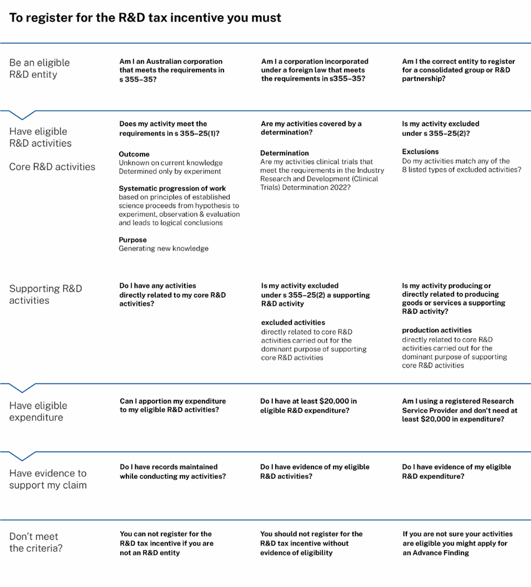

Eligible R&D activities
The R&DTI is for eligible R&D activities that you conduct and register. This part of the guide will help you assess if you conduct or plan to conduct eligible R&D activities.
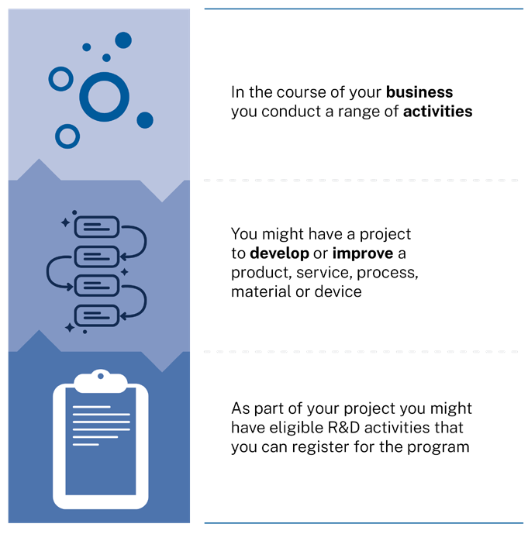

The main focus of your project may be research and development. However, you will likely conduct other activities that might not be eligible R&D activities.
Your business may not have a laboratory, a formal research team or usually undertake research and development. However, you may still conduct eligible R&D activities.
You may also vary how much R&D you conduct at different stages of your business journey. For example, you may conduct more R&D in your early years of operation if your company is a start-up that aims to develop a new product. As you start to market and sell your new product, you may conduct less R&D and focus on sales. You may then re-invest your sales revenue to conduct more R&D to improve your existing product, or develop a new product.

Eligible R&D activities are core and supporting R&D activities. This section of this guide will help you assess if your R&D activities are eligible.
We explain key terms in the legislation and provide examples. Any examples we provide are for guidance only. Even if your activities appear like the examples, they may not be eligible for the R&D Tax Incentive. Your activities must meet all of the legal requirements to be eligible R&D activities. You need to assess your activities based on your specific and individual circumstances. You must always assess your activities against the legal requirements, not just against this Guide.

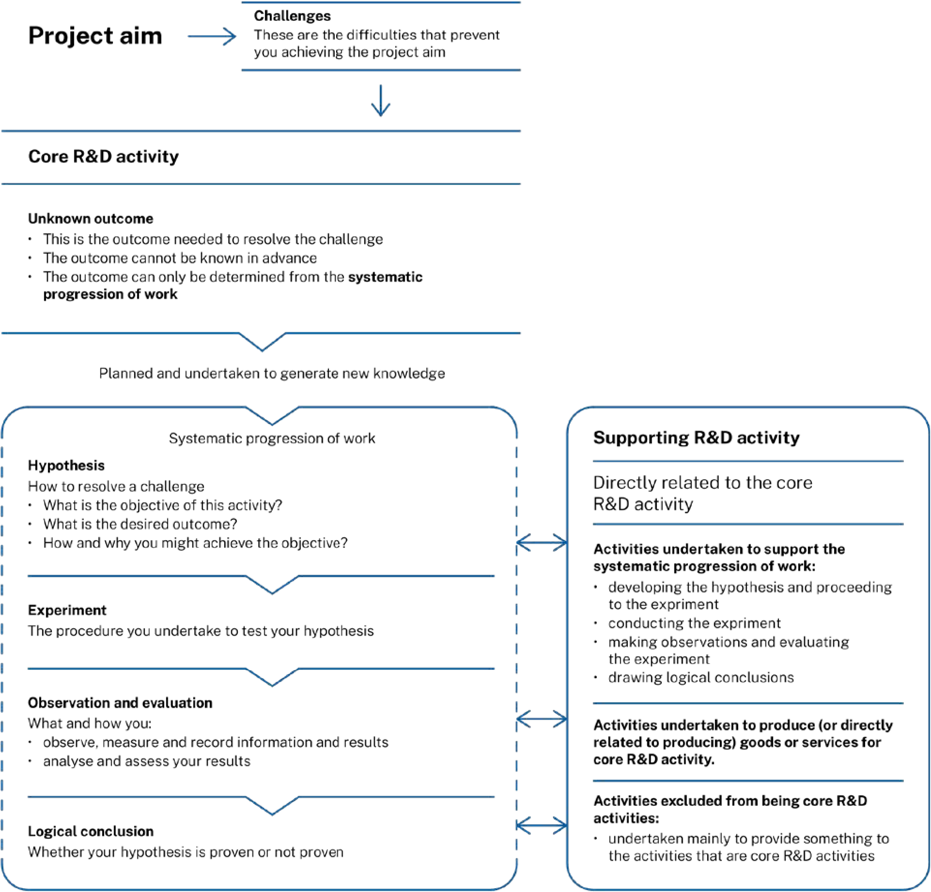

Projects and R&D activities
Entities often think of their R&D in terms of projects, but it’s important to remember that the R&D tax incentive only applies to eligible activities.
A project has an overall aim, and often has challenges making it hard to achieve this aim.
When facing a challenge, you might not know if or how you can overcome it. However, you will likely have ideas about how to achieve the result you want. If you cannot get that result using existing knowledge, you might need to try a new idea.
If that new idea is tested by conducting experimental activities in a scientific way, those activities might be eligible for the R&D tax incentive.

Core R&D activity
A core R&D activity starts with a hypothesis developed from a new idea about getting the result you want. This hypothesis will include how or why you might get this result.
Your hypothesis is then tested by an experiment or a series of experiments – a scientific procedure that is observed and evaluated to see if its results match what the hypothesis predicts. Following assessment of all recorded data and analysis of the results, a conclusion can then be drawn about the hypothesis.
This systematic progression of work must be conducted to generate new knowledge, and not to confirm a known fact or demonstrate existing knowledge.

Supporting R&D activities
You will likely need to undertake other activities to support your core R&D activity. If these activities are directly related to a core R&D activity, they might be supporting R&D activities.
If your supporting R&D activity involves or relates to producing goods or services, only the parts of these activities that have the dominant purpose of supporting the core R&D activity would be considered supporting R&D activities.
If an activity is excluded from being a core R&D activity but is directly related to, and is conducted for the dominant purpose of supporting, the core R&D activity, it could be a supporting R&D activity.

Core R&D activities
There are key terms for the R&D Tax Incentive that you need to understand. One of these is ‘core R&D activities’. You must conduct or plan to conduct, at least one core R&D activity to register for the R&DTI. Section 355–25(1) of the ITAA 1997, the law that applies to the program, states:
Core R&D activities are experimental activities
(a) whose outcome cannot be known or determined in advance on the basis of current knowledge, information or experience, but can only be determined by applying a systematic progression of work that:
(i) is based on principles of established science; and
(ii) proceeds from hypothesis to experiment, observation and evaluation, and leads to logical conclusions; and
(b) that are conducted for the purpose of generating new knowledge (including new knowledge in the form of new or improved materials, products, devices, processes or services).

Your activities must meet (a) and (b) above to be eligible as core R&D activities. They also must not be excluded activities. Section 355–25(2) of the ITAA 1997 lists excluded activities.

Outcome cannot be known or determined in advance
For an activity to be a core R&D activity, you cannot know or be able to determine the outcome of the activity based on current knowledge, information or experience anywhere in the world. The outcome needs to be one that you can determine only by applying a systematic progression of work.
Current knowledge, information or experience refers to knowledge that is reasonably accessible on a worldwide basis. It is knowledge available at the time you start your R&D activities. In this context knowledge, information or experience means the facts, information and skills acquired through experience or education, and the theoretical or practical understanding of a subject.
We expect you to search widely for an existing way to achieve your outcome before you start your R&D activity. We expect your records to show you did this.
You may not know or be able to determine the outcome in advance based on your knowledge, information or experience. You also need to assess that a competent professional in the relevant field:
- cannot know or determine the outcome based on knowledge, information or experience that is publicly available or reasonably accessible, anywhere in the world
- cannot know or determine the outcome of the core R&D activity without an experiment as part of a systematic progression of work.

Who is a competent professional?
A relevant competent professional is a person who in their field:
- has knowledge and experience
- has qualifications (if appropriate) or can otherwise act with a reasonable level of skill
- keeps up to date with developments
- has access to knowledge and resources around the world.
Such resources include the internet, relevant industry journals and other competent professionals in the field.
A competent professional will be a person who has knowledge, skills and experience in a field that relates to your R&D. This might be you or someone else in your organisation or industry sector, a consultant or an academic expert.

How will I know if information is available?
Information that is not reasonably accessible is not available. This may include information that is commercially sensitive and held by a competitor, such as a trade secret.
If the technical or scientific idea you are testing is in your area of expertise, then you may be aware of whether relevant knowledge, information or experience is available. Even if you or someone in your organisation is an expert in the field, you will need to research other sources to check that knowledge of how to achieve your outcome does not exist worldwide. You may:
- review scientific, technical or professional literature
- carry out internet searches
- conduct patent searches
- seek advice from an expert or experts.
We expect you to keep evidence of your enquiries.

Systematic progression of work
Your systematic progression of work needs to be based on principles of established science. Your systematic progression of work must include the following elements:
Logical
conclusions
Evaluation
Observation
Experiment
Hypothesis

All these elements need to be present within your activity. Your activity must meet all of the definition for it to be a core R&D activity. Other activities that are not one of these elements should not be included in your core R&D activity (although they could be supporting R&D activities).
Core R&D activities do not need to be completed in a single income year. You may plan to have elements of your systematic progression of work in different years. If you intend to conduct an eligible systematic progression of work it may not necessarily matter if your plans change. The parts of a core R&D activity you conducted in an income year need to be registered for that year.
We expect you to keep records to show your intent to conduct all elements of your systematic progression of work. We expect your evidence to show when and how your activities proceed from one element to the next and how they meet the definition of core R&D activities.
While the R&DTI is a self-assessment program, we may review your application. If we do, we will review your systematic progression of work as a whole.

Principles of established science
The systematic progression of work that you conduct or plan to conduct must be based on principles of established science. You must carry out your systematic progression of work according to a scientific approach, logically designed to test a hypothesis.
This means that your hypothesis has a scientific basis and the experiments, observations, evaluations and drawing conclusions are conducted in a scientific way.

Hypothesis
Your hypothesis is your idea or proposed explanation for how you could achieve a particular result and why that result may be achievable.
You may express your hypothesis in a single statement or in several statements that set out what you plan to do and why.
We expect you to explain:
- what result you aim to achieve
- how and why you think you can achieve it, informed by your background research.
Your hypothesis will guide your investigation. You need to develop it before you start your core R&D activities. You need to be able to test it through experiments you conduct to determine the outcome of your core R&D activities.
We expect you would have evidence that you developed your hypothesis before proceeding to experiment.

Experiment
An experiment is a scientific procedure that you undertake to test your hypothesis, observe what happens and compare this to what you expect. You may also compare your results to those from previous experiments. We expect you to explain how you conduct or plan to conduct your experiment. For example, you might describe the parameters you vary, those you hold constant, and those you observe or measure.
What you observe and evaluate in your experiment may support your hypothesis, or it may not. That is, you may get the result you expect, or you may get a different result. Either way, your activities may still be eligible for the R&DTI.
You may group a series of experiments into one core R&D activity if each aims to test the same technical or scientific idea.

Where can experiments take place?
Experiments can take place in many environments – from laboratories to process plants, offices or farms. Experiments in these different environments can also take different forms. The details and design of experiments may vary between industries and organisations, but they must aim to test a hypothesis as part of a systematic progression of work.

Observation and evaluation
Observation is where you observe, measure and record information and results that relate to your experiment. Such information can be qualitative (descriptive) or quantitative (numerical data).
Evaluation is where you assess and analyse the results of your experiments. You need to consider what the results of your experiment mean.
We expect your records to show that you evaluate the results of your experiment to understand why and how you achieve or do not achieve your desired outcome. You should analyse what occurs and when, how or why it occurs. We expect you to analyse data using established techniques. We also expect you to evaluate causal relationships between the parameters you vary, hold constant and measure in your experiment.

Leads to logical conclusions
The final part of the systematic progression of work is to draw logical conclusions about your hypothesis.
When you test your hypothesis through an experiment, your results may support your idea about how to achieve your desired outcome or they may not.
You need to form logical conclusions about why your results support your hypothesis or not. Your logical conclusion may be that you need to investigate different solutions and test a new hypothesis.
You could then test this new hypothesis through new experiments. Your new experiments may be similar enough to group with the same core R&D activity. Or, they may be different and need to be part of a new core R&D activity.

Evidence
We expect you to keep records that show you meet the legal requirements to register a core R&D activity for the R&DTI.
Your evidence needs to show that you conduct or plan to conduct all the elements of a systematic progression of work. These include:
- hypothesis
- experiment or sets of experiments to test your hypothesis
- observation and evaluation of results from your experiments
- the logical conclusions you draw about your hypothesis
Evidence that the outcome was not known on the basis of current knowledge can also be used to show if your core R&D activities are carried out to generate new knowledge. The nature of the new knowledge you intend to generate may also show when your activities are eligible. New knowledge is explained in the next section.

Purpose of generating new knowledge
There are two paragraphs in the legal definition of core R&D activities. Section 355-25(1) of the ITAA 1997 states:
Core R&D activities are experimental activities
(a) whose outcome cannot be known or determined in advance on the basis of current knowledge, information or experience, but can only be determined by applying a systematic progression of work that:
(i) is based on principles of established science; and
(ii) proceeds from hypothesis to experiment, observation and evaluation, and leads to logical conclusions; and
(b) that are conducted for the purpose of generating new knowledge (including new knowledge in the form of new or improved materials, products, devices, processes or services).

To be core R&D activities your activities need to meet both paragraphs (a) and (b) of the definition in s 355–25(1). They also must not be excluded activities. Section 355–25(2) of the ITAA 1997 lists excluded activities.

Your purpose
You need to conduct your activities to generate new knowledge. If when undertaking your activities your purpose is not to generate new knowledge, they will not meet the criteria.
You may decide to conduct your R&D for several reasons and activities in your R&D could also be conducted for different reasons. The purpose for conducting each of your claimed core R&D activities will be apparent from the evidence. Your activities will meet paragraph 355–25(1)(b) when it can be shown the activity is carried out to generate new knowledge.
For example, you may apply a systematic progression of work to determine an outcome that couldn’t be determined in another way. You may later rerun that systematic progression of work as a demonstration when familiarising new staff with your research methods. In the first instance, it may be easy to show the activity is conducted to generate new knowledge, and that it would meet the requirements of paragraph (b). In the second instance, it would be harder to show the activity is conducted to generate new knowledge, and it would not meet the requirements of paragraph 355–25(1)(b).

What is new knowledge?
New knowledge can be either general or applied. It may be a new theoretical or practical understanding of a subject. It also may be in the form of a new or improved material, product, device, process or service.
What makes this new is that the knowledge does not already exist and it adds to the current knowledge.
Example
Your experiment aims to produce the new information you need to solve a problem or to develop a new or improved product or process. The theoretical or practical understanding you are trying to discover from your experiment is new knowledge.
You are aiming to develop a material, product, device, process or service. This is new knowledge when it does not already exist, or its new form improves on what does exist.

Evidence
We expect you to keep records to show that you meet the legal requirements to register an activity as a core R&D activity for the R&DTI.
Whether your activities are carried out for the purpose of generating new knowledge (including new knowledge in a general or applied form) depends on the particular circumstances for each activity or group of activities. This needs to be decided based on the evidence for each activity.
We expect your records to reflect what your purposes for carrying out the activities are at the time you start your activities. You need to assess whether you carry out your activities to generate new knowledge at that time.
Your evidence needs to show that your characterisation you are conducting your activity to generate new knowledge is accurate.
When you make and keep records, it is important you include evidence of your purpose. Read the evidence section for examples of records that could support your claim.
A wide range of evidence can be used to show you conducted your activities to generate new knowledge. You may use how you decided to conduct your activities because the outcome could not be determined from current knowledge. You might also show how conducting your activities is intended to generate new knowledge in the form of new or improved materials, products, devices, processes or services. Recording why you decided to conduct the activities to determine that outcome or to generate that new applied knowledge can show your purpose is generating new knowledge.
For more about the R&D Tax Incentive
- Visit business.gov.au – Research and Development Tax Incentive
- Contact us on 13 28 46

Are my activities core R&D activities?
To assess that your activities are core R&D activities you must assess that they meet the requirements of s 355–25 of the ITAA 1997. So far in this guide we have provided general guidance on how we apply the requirements of s 355–25(1) of the ITAA 1997. In the next section we provide guidance on how we apply s 355–25(2) of the ITAA 1997.
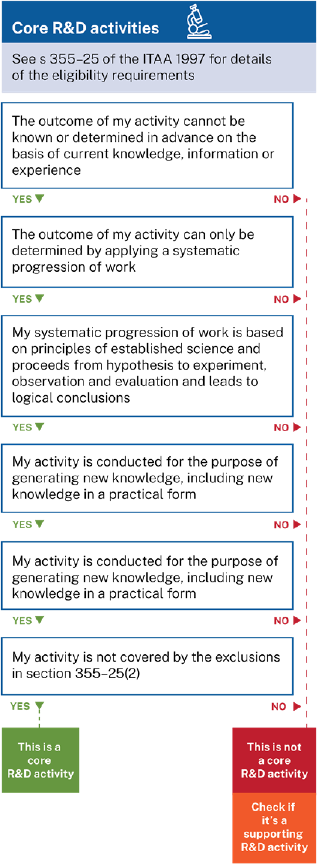

Exclusions
There are activities that are excluded from being core R&D activities. They cannot be registered as core R&D activities. You must check if any of your activities are excluded from being core R&D activities.
Activities that are excluded from being core R&D activities may qualify as supporting R&D activities if they meet the definition. These activities will be supporting R&D activities if they are directly related to a core R&D activity and you conduct them for the dominant purpose of supporting at least one core R&D activity. Read the sections on supporting R&D activities and dominant purpose later in this guide.
Excluded activities
The law, at s 355–25(2) of the ITAA 1997, lists those activities that cannot be core R&D activities for the R&DTI:
- market research, market testing or market development, or sales promotion (including consumer surveys);
- prospecting, exploring or drilling for minerals or *petroleum for the purposes of one or more of the following:
  - discovering deposits;
  - determining more precisely the location of deposits;
  - determining the size or quality of deposits;
(c) management studies or efficiency surveys;
- research in social sciences, arts or humanities;
- commercial, legal and administrative aspects of patenting, licensing or other activities
- activities associated with complying with statutory requirements or standards, including one or more of the following:
  - maintaining national standards;
  - calibrating secondary standards;
  - routine testing and analysis of materials, components, products, processes, soils, atmospheres and other things;
- any activity related to the reproduction of a commercial product or process
  - by a physical examination of an existing system; or
  - from plans, blueprints, detailed specifications or publically available information
- developing, modifying or customising computer software for the dominant purpose of use by any of the following entities for their internal administration (including the internal administration of their business functions):
- the entity (the developer) for which the software is developed, modified or customised;
  - an entity *connected with the developer;
  - an *affiliate of the developer, or an entity of which the developer is an affiliate.

(a) market research, market testing or market development, or sales promotion (including consumer surveys)
Market research, testing and development and sales promotion (including consumer surveys) are activities that cannot be core R&D activities for the R&DTI. Sometimes, companies undertake these activities to resolve market or economic uncertainty, rather than technical or scientific uncertainty.
Activities that this exclusion covers include those to:
- discover consumer interest for products or services
- discover consumer preferences about the characteristics of products or services
- promote interest in, or the consumption of, products or services.
Examples
You need to conduct experiments to develop a new product. You use the information you collect from a consumer survey to help you design the experiments you conduct. If your dominant purpose is to support your core R&D activity, then this may be eligible as a supporting R&D activity if it is also directly related to your core R&D activity.
If your dominant purpose for collecting the information is to help you design a marketing strategy for your product or service, it would not be eligible as a supporting R&D activity. This is because your dominant purpose is not to support a core R&D activity.

(b) prospecting, exploring or drilling for minerals or *petroleum for the purposes of one or more of the following:
(i) discovering deposits
(ii) determining more precisely the location of deposits
(iii) determining the size or quality of deposits.
Your activities that involve prospecting, exploring or drilling for minerals or petroleum, and that you conduct for one or more of the three listed purposes, cannot be core R&D activities.
If your activities involve prospecting, exploring or drilling for minerals or petroleum, assess whether you conduct them to discover deposits, determine the precise location of deposits, or determine the size or quality of deposits. If you do not conduct these activities for one or more of these purposes they are not excluded from being core R&D activities. For example, if you drill for samples that you analyse as part of an experiment.
Activities this exclusion covers include prospecting, exploring or drilling activities to:
- find deposits of minerals or petroleum
- pinpoint a more exact location of deposits
- find out how much of a mineral or petroleum is in a location
- analyse how pure a mineral or petroleum deposit might be
- determine the commercial value of a deposit.

What is petroleum?
Petroleum is defined in s 40–730(6) of the ITAA 1997 as:
(a) any naturally occurring hydrocarbon or naturally occurring mixture of hydrocarbons, whether in a gaseous, liquid or solid state; or
(b) any naturally occurring mixture of:
(i) one or more hydrocarbons, whether in a gaseous, liquid or solid state; and
(ii) one or more of the following: hydrogen sulphide, nitrogen, helium or carbon dioxide;
whether or not that substance has been returned to a natural reservoir.

The terms prospecting, exploring, drilling and minerals are given their ordinary meaning.
Examples
You drill for mineral samples and analyse the samples to evaluate the quality of the deposit. You then use the information to design, conduct or evaluate experiments within a systematic progression of work to develop a new or improved mineral refining process. Where your dominant purpose when drilling for the mineral samples is to support your core R&D activity, then these activities may be supporting R&D activities if they are directly related to your core R&D activity.
If your dominant purpose is to determine whether you will be able to extract the minerals economically using established mining and refining processes, then they will not be eligible as supporting R&D activities.

(c) management studies or efficiency surveys
Management studies and efficiency surveys are activities that cannot be core R&D activities for the R&DTI.
You need to assess whether you conduct activities to collect and evaluate information to help you to make decisions about the operations of your business or any other business. This exclusion covers those activities that study or survey management or business operations, or their efficiency.
The exclusion includes studies or surveys you conduct to measure or evaluate certain data. For example:
- the energy efficiency of a business
- the productivity of employees, such as time and motion studies
- management capability
- cost savings for a business
- time-saving measures for a business
The exclusion does not include studies or surveys unrelated to business or operational management you conduct as part of a systematic progression of work. For example, to measure or evaluate:
- the energy efficiency of a new or improved electronic product or device that you develop
- the physical efficiency, of a new or improved product or process that you develop
Examples
You use the information you collect from an energy efficiency survey to help you to design and conduct experiments to develop a new building environmental management software. If your dominant purpose for conducting the surveys is to support your core R&D activity, then they may be eligible as supporting R&D activities if they meet all requirements for supporting R&D activities.
If your dominant purpose is to help you decide how to use energy in your business, then your surveys would not be eligible as supporting R&D activities.

(d) research in social sciences, arts or humanities
Activities that involve experimental and nonexperimental research in social sciences, arts or humanities are activities that cannot be core R&D activities for the R&DTI.
When you assess your activities, you need to assess whether you conduct research in these areas, even if this is not your area of primary business operations.
In social sciences, arts or humanities, you conduct research when you gather or compare information, or conduct an experiment or some other inquiry or investigation.
Depending on the circumstances, the exclusion is likely to apply to these subject areas:
- anthropology
- business
- classics
- communication studies
- dance
- economics
- education
- fine art
- geography
- history
- literature
- music
- performing arts
- philosophy
- politics
- psychology (neuropsychology is not excluded)
- sociology
- theatre
- visual arts
This list is not exhaustive. You should consider your individual circumstances when you assess whether your activities involve research in social sciences, arts or humanities.
For example, the exclusion covers activities you conduct that include:
- study of business or economic theory, functions or processes
- design, production or performance of artistic expression
- study of individuals, society, social functions or relationships
- study or the production of literature.

Examples
You develop a mobile app for users to learn languages and your aim is a new teaching method that will result in faster or easier learning. The knowledge you seek is about the teaching method. Your activity would be excluded.
You conduct a study of the learning styles of individuals. You assess that your study is excluded from being a core R&D activity as it involves research in social sciences. You use the information you collect from the study to help you design and conduct experiments to develop a new brain sensor. Through your core R&D activities, you aim to develop a sensor that can detect brain wave frequencies to tailor a learning experience for individual users. If your dominant purpose to conduct the study is to support your core R&D activity, then the study may be eligible as a supporting R&D activity. It will need to meet all requirements for a supporting R&D activity. If your dominant purpose to conduct the study is to help you understand how individuals learn, then it would not be eligible as a supporting R&D activity.

(e) commercial, legal and administrative aspects of patenting, licensing or other activities
Intellectual property (IP) activities cannot be core R&D activities for the R&DTI.
Your ideas and inventions and the new knowledge you generate about them are your IP. If you conduct core R&D activities to generate new knowledge, then that new knowledge is your IP.
You might also generate IP in other areas of your business. Generally, activities that you conduct to generate IP are not covered by this exclusion.
For example: Experiments you conduct to develop a new product or process that you intend to protect with a patent are not excluded from being core R&D activities for the R&DTI.
Yet, activities that you conduct to generate IP are not always core R&D activities.
For example: You invent a new product or process (your IP). You can develop it without the need for experiments because you can know or determine the outcome in advance. This would not be a core R&D activity for the R&DTI because it does not follow a systematic progression of work for which the outcome could not be known or determined in advance.
This exclusion includes commercial, legal and administrative activities you conduct to:
- gain rights to use or access IP from another party
- grant rights to another party to use or access your IP
- negotiate an IP sharing agreement
- negotiate non-disclosure agreements
- research, prepare and file an application to protect your IP
Examples
You conduct a patent search to gather information to refine your hypothesis and design the experiments that you conduct to test your hypothesis. If your dominant purpose for the patent search is to allow you to design and conduct your experiments, then this may be eligible as a supporting R&D activity. Your activity will need to meet all requirements for supporting R&D activities. If your dominant purpose is to establish a gap in the market for your products or services, it will be excluded.

What forms of IP are covered by this exclusion?
Forms of IP covered by this exclusion include:
- designs
- domain names
- patents
- plant breeder’s rights
- trademarks
- your know-how or proprietary knowledge
For more information about IP, visit the IP Australia website ipaustralia.gov.au – Understanding intellectual property

(f) activities associated with complying with statutory requirements or standards, including one or more of the following:
(i) maintaining national standards
(ii) calibrating secondary standards
(iii) routine testing and analysis of materials, components, products, processes, soils, atmospheres and other things.
Activities you conduct to meet a requirement or standard contained in legislation or that are associated with meeting such laws, cannot be core R&D activities for the R&DTI.
Activities that you must conduct to meet requirements or standards contained in legislation are covered by this exclusion. This includes activities that a regulator directs you to conduct as required under legislation.
You may need to comply with legal standards or requirements when conducting your R&D activities. Your R&D activities are not covered by this exclusion just because you must conduct them in a regulated manner.
Activities you undertake to show compliance with legal standards or requirements are covered by the exclusion.
Examples
Clinical trials you conduct to develop a new or improved drug or device are not excluded from being core R&D activities. Yet, activities that you must conduct to comply with the legal requirements of your clinical trial are excluded. They cannot be core R&D activities. This might include where you prepare and submit your application to a regulator to seek approval to conduct your trial where this application is required by legislation.
Your business is a mining company, and the regulator requires you to produce an environmental impact statement under the relevant environmental legislation to show compliance for your site. You conduct a study to determine the potential impacts on flora and fauna in the area. This would be an excluded activity because the law requires you to conduct the study.
Activities this exclusion covers include those you conduct where required by legislation to:
- show compliance with national standards
- calibrate a secondary standard with reference to a primary standard
- routinely test for compliance of your materials, components, products, or processes.
- gain certification of your materials, components, products, or processes
- routinely test soils, atmospheres and other things for compliance with a legislative requirement. For example, requirements for environmental protection.
Activities covered by this exclusion can be supporting R&D activities if the activities are directly related to a core R&D activity and your dominant purpose is to support one of your core R&D activities. This may include if you gather information such as the qualitative or quantitative data you need to conduct your systematic progression of work.
Examples
You apply to the Therapeutic Goods Administration to gain approval to conduct a clinical trial. If your dominant purpose to gain approval is to allow you to conduct the trial, these activities can qualify as supporting R&D activities. They must be directly related to your clinical trial and your clinical trial must meet all requirements for core R&D activities.
You conduct routine tests on your product to show they meet a statutory requirement or standard. If the reason you test some groups of products is to use them in core R&D activities, then testing these products can be supporting R&D activities.

(g) any activity related to the reproduction of a commercial product or process:
(i) by a physical examination of an existing system
(ii) from plans, blueprints, detailed specifications or publically available information.
Activities that cannot be core R&D are those you conduct to reproduce a commercial product or process by examining:
- the actual product or process
- plans, blueprints, detailed specifications or publicly available information.
Your activities are not excluded from being core R&D activities if you conduct them to:
- reproduce a product or process in some way other than those listed above
- develop a new or improved product or process
- develop a new or improved method for creating an existing product or process.
Excluded activities include those you conduct to:
- obtain documents that tell you how a product or process works, or how to produce it
- analyse a sample of a product to gain information about how to make the product
- collect data about the operating parameters of a production process, so that you can replicate the process.
Your activities to gather information, including qualitative or quantitative data about an existing product or process, can be supporting R&D activities. They must be directly related to your core R&D activity, and your dominant purpose must be to support your core R&D activity.
Examples
You reproduce an industrial process from the information you find in academic papers or patents. If your dominant purpose is to collect data to help you refine your hypothesis about how to improve the process or develop a new process, this can qualify as supporting R&D activities. If your dominant purpose is to understand the process so you can replicate it exactly, this will not qualify as supporting R&D activities.

(h) developing, modifying or customising computer software for the dominant purpose of use by any of the following entities for their internal administration (including the internal administration of their business functions):
(i) the entity (the developer) for which the software is developed, modified or customised
(ii) an entity *connected with the developer
(iii) an *affiliate of the developer, or an entity of which the developer is an affiliate.
If you conduct activities to develop, modify or customise computer software, you need first to assess if the software is for use by you, an entity connected with you, or an entity affiliated with you. If it is, you then need to assess if the dominant purpose of using the software is for either your (or that entity’s) internal administration, or the internal administration of your (or that entity’s) business functions.
Activities that you conduct to develop, modify or customise computer software include those to:
- design software
- write new code or modify existing code
- test software
- customise an off-the-shelf software package. For example, to make the software perform a different function.
The software might not be developed, modified or customised for the dominant purpose of use by you, a connected entity or an affiliated entity. The dominant purpose for using the software might not be the internal business administration or internal administration of a business function.
In these cases you only need to assess if the activities to develop, modify or customise the software meet the requirements for a core R&D activity or a supporting R&D activity.
Examples
You have a range of software you sell to other businesses to use for their internal business administration (including internal administration of their business functions). Developing, modifying or customising your software products is not excluded from being a core R&D activity, as the dominant purpose of use is the internal administration of companies that are not connected or affiliated with you. You will need to assess that the activity meets the other requirements for an R&D activity for you to register it for the R&DTI.
To determine if the dominant purpose is use by you, or entities connected or affiliated with you, for internal business administration, you need to consider which entities the software is being developed, modified or customised for, and then how those entities will use that software. You then need to consider the strength of each purpose and how important each is compared to the other purposes for using the software.
There may be several purposes for using software, but you can only have one dominant purpose.
The exclusion does not apply when you develop, modify or customise software for a dominant purpose of use by you, or entities connected or affiliated with you, other than for internal business administration. This may include software you develop, modify or customise that:
- forms part of an electrical or mechanical device, such as industrial equipment or consumer products
- you used to collect and analyse data from experiments
- is used by your customers and is unrelated to your internal administration.
You may assess your internal administration software development activities as core R&D activities that are not subject to this exclusion. If so, we expect to see records that support your assessment around internal administration and your dominant purpose.
Activities covered by this exclusion may be supporting R&D activities if the activities are directly related to a core R&D activity and your dominant purpose for conducting those activities is to support a core R&D activity.
If you assess your activities as supporting R&D activities you will need to show how the software development, modification or customisation activities are directly related to your core R&D activities and how the dominant purpose of the activities was supporting at least one of those core R&D activities. We expect you have records that support your assessment.

What is software for internal administration?
Software for internal administration functions include:
- business applications such as payroll and accounting, invoicing, ordering, quality control reports and information management
- management information systems
- enterprise resource planning.

Connected and affiliate entities
Your company is connected with another company if either entity controls the other entity, or both entities are controlled by the same third entity. Control is not limited to having more than 50% of the shares in the entity.
Your company is an affiliate with another company if that company acts or you can expect it to act according to the directions or wishes of your company.
These relationships do not apply simply because your company has a commercial relationship with another company – such as with a supplier.
The meaning of the terms connected and affiliate are defined in sections 328–125 and 328–130 of the ITAA 1997.
For more information visit ato.gov.au – Research and Development Tax Incentive

For more about the R&D Tax Incentive
- Visit business.gov.au – Research and Development Tax Incentive
- Contact us on 13 28 46

Supporting R&D activities
The legislation, at s 355-30 of the ITAA 1997, states:
Supporting R&D activities
(1) Supporting R&D activities are activities directly related to core R&D activities
(2) However, if an activity:
(a) is an activity referred to in subsection 35525(2); or
(b) produces goods or services; or
(c) is directly related to producing goods or services.
the activity is a supporting R&D activity only if it is undertaken for the dominant purpose of supporting core R&D activities.

After you assess that you conduct or plan to conduct at least one core R&D activity, you can assess whether you conduct any activities that meet the definition of supporting R&D activities.

Directly related activities
You need to identify the core R&D activity to which your supporting R&D activity is directly related. We also expect you to identify the relationship of the activity with the elements in your systematic progression of work.
We expect you to identify and record what that relationship is when you conduct your activities and to explain what that relationship is when you apply to register your activities.
Whether your supporting R&D activity is directly related to a core R&D activity will depend on your circumstances. We expect you to analyse your specific circumstances and keep records to support your claim.
Examples
a literature review to refine your hypothesis before you conduct your experiment
you clean and maintain the equipment you use during experiments
you decommission and dismantle equipment you used in experiments after you have reached logical conclusions.

R&D activities in different years
You can conduct supporting R&D activities before, during or after your core R&D activity.
When you plan your R&D, you may schedule activities over different years.
You may conduct your supporting R&D activity in a different year to your core R&D activity. If you do this, you will need to specify your core R&D activity when you apply to register your supporting R&D activity.
We recognise that R&D is uncertain and your plan may change. Although you may describe intended core R&D activities in your registration, you may not conduct those activities. You should explain these changes to your planned core R&D activities to us when you apply to register.

Examples
You plan to conduct R&D at the same time as you conduct your other business activities. Your plan includes initial designs for the experiments and a schedule for the R&D activities over three years. In the first year, you conduct an extensive literature review and consult with experts in the field. You use this information to plan your systematic progression of work. In year 2, you start your core R&D activities and document the experiments that you conduct. Year 3, you continue your experiments in a pilot plant and observe results from your experiments. In year 3, you evaluate results from your experiments. Year 4 is where you plan to apply the new knowledge you generate to move to full-scale production if your hypothesis is supported. You may need to undertake further activities to apply the results to production. You will need to assess whether your later activities meet the requirements for eligible R&D activities. You may not know this until after you evaluate the results of your experiments.
Your literature review and research may be registered for year 1 as a supporting R&D activity if you can be specific about the core R&D activities you intend to conduct in years 2 and 3 which these activities will be directly related to. We will expect to see your records that show in year 1 you planned to conduct core R&D activities in years 2 and 3. Your records will need to show that you meet the requirements as an R&D entity, and you plan to conduct at least one core R&D activity.

What activities are not supporting R&D activities?
Activities that are not directly related to at least one of your core R&D activities cannot be supporting R&D activities. Your activities are likely directly related to your core R&D activities if they support you to conduct your systematic progression of work.
Examples of activities that will not usually have a direct relationship to a core R&D activity include:
- a literature review or internet search that you conduct to identify a market niche for a new product
- you clean and maintain equipment that you do not use for an experiment
- you decommission and dismantle equipment that you did not use to conduct experiments.

Key aspects of supporting R&D activities
- Each supporting R&D activity must be directly related to at least one core R&D activity. You must be able to specify this core R&D activity or these core R&D activities
- Several supporting R&D activities may be directly related to a particular core R&D activity
- Supporting R&D activities may be undertaken before, during or after its core R&D activity. You must be able to be specific about a core R&D activity that will be conducted after its supporting R&D activity.

Dominant purpose

When do I need to have the dominant purpose of supporting a core R&D activity?
Supporting R&D activities must be directly related to a core R&D activity. Some directly related activities must also be conducted for the dominant purpose of supporting your core R&D activities to be eligible as supporting R&D activities. These include activities that:
- are excluded from being core R&D activities
- produce goods or services
- are directly related to producing goods or services
In any of these circumstances, you need to assess whether you conduct each of these activities for the dominant purpose of supporting a core R&D activity.

What is dominant purpose?
Dominant purpose means your prevailing or most influential purpose. Your main purpose of conducting your activities must be to support a core R&D activity.

How do I assess my dominant purpose?
To determine your dominant purpose to conduct an activity, you need to consider all your purposes. You then need to consider the strength of each purpose and how important it is compared to your other purposes.
You need to consider:
- how and when you conduct your activity or establish the need to conduct your activity. This will usually be when you plan or conduct your core R&D activity
- what other purposes you have to conduct your activity and whether one of the other purposes is more influential
- how you conduct your activity for the dominant purpose of supporting a core R&D activity. Ask what your activity involves, and why you need it to conduct an element of your systematic progression of work for your core R&D activity
- whether your activity goes beyond activities you would have conducted if you did not conduct your core R&D activities.
Activities that are likely to have the dominant purpose of supporting a core R&D activity include activities that:
- have no purpose other than to assist or facilitate a core R&D activity
- support core R&D activities and where the commercial benefit is insignificant
- produce items that you consume, or you expect to consume in your experiment
- create a component to use in a core R&D activity where it serves no other purpose. For example, a part of the experimental apparatus.
Activities that are unlikely to have the dominant purpose of supporting a core R&D activity include those that:
- produce a good or service that you do not use to conduct an experiment
- you would undertake if you did not conduct R&D.

Activities that produce goods and services
For your supporting R&D activities that produce or are directly related to producing goods, you must be able to show that you conduct them for the dominant purpose of supporting a core R&D activity. This is regardless of the scale of manufacture or the end user of the goods.
Also, you must be able to show that you undertake your supporting R&D activities that produce or are directly related to producing services for the dominant purpose of supporting a core R&D activity. This is regardless of the terms of the services. This includes services your business provides to itself or to another entity. It also includes services another entity provides to your business.
Whether you conduct an activity for the dominant purpose of supporting a core R&D activity will depend on your specific circumstances. We expect you to analyse and explain your circumstances and keep evidence to support your claim.
For more about the R&D Tax Incentive
- Visit business.gov.au – Research and Development Tax Incentive
- Contact us on 13 28 46

Evidence
We expect you to be able to provide evidence that shows how you conduct or plan to conduct core R&D activities:
- that are based on principles of established science
- whose outcome cannot be known or determined in advance on the basis of current knowledge, information or experience worldwide
- whose outcome can only be determined by applying a systematic progression of work - hypothesis, experiment, observation and evaluation, leading to logical conclusions
- for the purpose of generating new knowledge
- that are not excluded from being core R&D activities.
We expect you to maintain records of activities that you register or plan to register for the R&DTI. In your systematic progression of work, we expect you maintain details of how you:
- develop your hypothesis
- design your experiment
- observe and record the results of your experiment
- evaluate your results
- reflect conclusions about your results. Do they support your hypothesis or generate other new knowledge?
We also expect you maintain evidence that shows that your supporting R&D activities are directly related to at least one core R&D activity and, when needed, that you conduct them for the dominant purpose of supporting a core R&D activity. Evidence can include written records, oral statements and expert opinions.

What happens if we review your registration?
When we review or examine your registration or application, we will ask for evidence to show that you have conducted, are conducting or plan to conduct eligible R&D activities. We will assess your activities on the evidence you supply to us. We sometimes also conduct our own research. We will use all available information to assess whether your R&D activities are eligible for the R&DTI.
In our work, we follow principles of procedural fairness. We will allow you to comment on information we find that we will rely on when we assess your R&D activities.
We will base our assessment on the legal requirements in the ITAA 1997. We will work with you to ensure you have the opportunity to provide evidence to support your claim. We may ask to speak with technical staff you employ or contract.
Types of records we consider if we assess the eligibility of your R&D activities include:
- contemporaneous: records you make around the time you plan and conduct activities are your evidence as to why and how you conduct your activities
- non-contemporaneous: records that you create outside the period of your R&D activity, yet relate to that R&D activity.
We expect that you will make records before or around the time you conduct your activities. These will be the strongest evidence of your R&D activities.
We expect you to keep records so that you can provide them to us if we review your application for the R&DTI. Your systems and processes that identify, evaluate and record your eligible R&D activities and expenditure will be evidence to support your claim.
If we find that your evidence does not support your claims, we will give you the opportunity to provide further detail. If you are unable to supply evidence to support your claims, we may find that you did not conduct or plan to conduct eligible R&D activities.
For more about reviews or examinations visit business.gov.au – How we check R&D Tax Incentive compliance

Records to show eligibility
Listed below are some examples of records that may show aspects of your R&D activities. Many of these are general business documents and may not by themselves establish the eligibility of your R&D activities. Together with other evidence, these documents may support your eligibility.

Table 1 Evidence for core R&D activities
Eligibility requirement | Examples of evidence
The outcome of the experiments (whether the hypotheses were true or false) could not have been known or determined in advance.  This requirement is assessed using the concept of a competent professional on the basis of the knowledge, networks, and information they could reasonably gain access to, and whether with this knowledge they would be able to predict the outcome of the activity in advance. | - records of literature reviews  - communications with industry experts (emails, minutes, notes and similar)  - screenshots of questions posted on tech blogs  - details of failed attempts to use existing technology
Experiments are conducted for the purpose of generating new knowledge. | - minutes of board, project or team meetings where the need to conduct experiments was discussed
Expenditure is clearly incurred on an eligible R&D activity.  The expenditure you can claim as R&D expenditure is limited to the extent it is incurred on R&D activities. Therefore, you must show that the amounts you are claiming on your tax return have been incurred on the core and supporting R&D activities you have registered with the department.  Your records must be sufficient to verify the amount of the expenditure incurred on R&D activities, the nature of the R&D activities and the relationship of the expenditure to the activities.  You must use reasonable methods to differentiate between expenditure on eligible R&D activities and other activities. Where contractors are undertaking some or part of the work, you need to keep written agreements that set out the work to be undertaken, who performed the work and where it took place. If this applies to you, you should also look at ‘For whom are the R&D activities conducted’ on the ATO website. | Working papers demonstrating how the R&D claim was calculated, including:  - exported content from task tracking or project management tools (demonstrating the actual time that staff worked on eligible activities)  - contracts, schedules and invoices for any work, or parts of the work, undertaken by contractors  - design and scoping documents showing how purchased items were used in experiments  - how you determined the time your utilities (excluding capital costs) were used for eligible R&D activities  - working papers demonstrating how particular items of expenditure were allocated to each of the registered core and supporting R&D activities, and how the R&D claim was calculated

Table 2. Evidence for supporting R&D activities
Eligibility requirement | Examples of evidence
Supporting R&D activities directly related to an eligible core R&D activity. | - technical records showing how and why the supporting R&D activity is directly related to one or more core R&D activities  - for example:  - why a graphical user interface that is being claimed was necessary to conduct the experiments in a core R&D activity  - conduct technical background research  - set up and facilitation of experiments  - building of proof of concepts/ prototypes  - internal testing and user testing
Where supporting R&D activities:  - are excluded from being core R&D activities  - produce goods or services, or  - are directly related to producing goods or services  the dominant purpose of conducting these activities must be to support a core R&D activity (rather than it being for a purpose of secondary importance – to satisfy the dominant purpose test, the purpose of undertaking the activities must be the most important purpose).  This is often a requirement where software has been developed to facilitate an experiment in an eligible core R&D activity on a production line.  You must only claim expenditure incurred on those goods or services which are used in the eligible R&D activities and not for commercial production runs, and your documents should support this. R&D entities that sell or use the product of their eligible R&D need to consider the ‘feedstock adjustment rules’ (which are available on the ATO website) and include the necessary feedstock adjustment amount in their income tax returns. | - where manufacturing takes place in conjunction with software-related activities, your evidence may be production run sheets and quality control sheets that identify which units were used for experiments and which were to be sold  - where saleable goods are produced in an activity, your records need to show that you produced sufficient numbers for the experiments and not so many goods that this demonstrates a dominant commercial purpose  - we expect you to document how that activity supports the core R&D activity and satisfies the dominant purpose requirement  - where software development occurs in a manufacturing or production environment, we also refer you to the ‘Manufacturing sector guide for the R&D Tax Incentive’

Other guides
This guide is our primary guide to explain the key terms of the R&D Tax Incentive. We have more guides on at Assess if your R&D activities are eligible for the R&D Tax Incentive - additional guidance material.

We also have a case study showing how you can self assess and register eligible activities at Hypothetical case study: Far Side - R&D in a new space.

List of guides
Agrifood Agrifood sector guide for the R&D Tax Incentive
Agrifood is a highly integrated value chain spanning food and beverage enterprises from paddock to plate
Biotechnology Biotechnology sector guide for the R&D Tax Incentive
Biotechnology includes the subsectors of life sciences, industrial processing, agriculture and environment
Built Environment Built environment sector guide for the R&D Tax Incentive
The built environment is the material, spatial and cultural product of human labour and imagination.
Energy Energy sector guide for the R&D Tax Incentive
The energy sector covers generation, distribution, storage, transport and emerging technologies.
Manufacturing Manufacturing sector guide for the R&D Tax Incentive
The manufacturing sector produces everything from fast moving consumer goods to aerospace components.
Software development Software development sector guide for the R&D Tax Incentive
External appeals External review of R&D Tax Incentive decisions
Learn about judgments from the Administrative Appeals Tribunal (AAT) and Federal Court of Australia.
Federal Register of Legislation Federal Register of Legislation
Australian Taxation Office ato.gov.au – Research and development tax incentive

For more about the R&D Tax Incentive
- Visit business.gov.au – Research and Development Tax Incentive
- Contact us on 13 28 46
- Attend one of our information sessions, register at business.gov.au - R&D Tax Incentive events and information sessions
For more on expenditure related record keeping visit ato.gov.au – Research and Development Tax Incentive

Subscribe to the R&D Tax Incentive Insider or the R&D Tax Insider Plus newsletter to receive updates on guidance, taxpayer alerts, program trends, and topical news .

