Space Infrastructure Fund:
Space Payload Qualification Facilities

Opening date: | 17 November 2020
Closing date and time: | 5:00pm Australian Eastern Daylight Savings Time on 21 January 2021  Please take account of time zone differences when submitting your application
Commonwealth policy entity: | Australian Space Agency
Administering entity: | Department of Industry, Science, Energy and Resources
Enquiries: | If you have any questions, contact us on 13 28 46
Date guidelines released: | 17 November 2020
Type of grant opportunity: | Open competitive

Contents
1. Space Infrastructure Fund: Space Payload Qualification Facilities Grant processes 4
2. About the grant program 5
2.1. About the Space Payload Qualification Facilities grant opportunity 5
3. Grant amount and grant period 7
3.1. Grants available 7
3.2. Project period 7
4. Eligibility criteria 7
4.1. Who is eligible? 7
4.2. Additional eligibility requirements 8
4.3. Who is not eligible? 8
5. What the grant money can be used for 8
5.1. Eligible activities 8
5.2. Eligible expenditure 9
5.3. What you cannot use the grant for 9
6. The assessment criteria 10
6.1. Assessment criterion 1 10
6.2. Assessment criterion 2 10
6.3. Assessment criterion 3 11
7. How to apply 11
7.1. Attachments to the application 12
7.2. Joint applications 12
7.3. Timing of grant opportunity 12
8. The grant selection process 13
8.1. Who will approve grants? 13
9. Notification of application outcomes 14
10. Successful grant applications 14
10.1. Grant agreement 14
10.2. Space Payload Qualification Facilities specific legislation, policies and industry standards 14
10.3. How we pay the grant 15
10.4. Tax obligations 15
11. Announcement of grants 15
12. How we monitor your grant activity 15
12.1. Keeping us informed 15
12.2. Reporting 16
12.2.1. Progress reports 16
12.2.2. End of project report 16
12.2.3. Post project report 17
12.2.4. Ad-hoc reports 17
12.3. Independent audits 17
12.4. Compliance visits 17
12.5. Grant agreement variations 17
12.6. Evaluation 18
12.7. Grant acknowledgement 18
13. Probity 18
13.1. Conflicts of interest 18
13.2. How we use your information 19
13.2.1. How we handle your confidential information 19
13.2.2. When we may disclose confidential information 19
13.2.3. How we use your personal information 19
13.2.4. Freedom of information 20
13.3. Enquiries and feedback 20
14. Glossary 21
Appendix A. Australian Space Qualification Services Audit Report Summary 23

Space Infrastructure Fund: Space Payload Qualification Facilities Grant processes
The Space Infrastructure Fund is designed to achieve Australian Government objectives
This grant opportunity is part of the above grant program which contributes to the Department of Industry, Science, Energy and Resources Outcome’s 1: Enabling growth and productivity for globally competitive industries through supporting science and commercialisation, growing business investment and improving business capability and streamlining regulation. The Department of Industry, Science, Energy and Resources and the Australian Space Agency work with stakeholders to plan and design the grant program according to the Commonwealth Grants Rules and Guidelines.
⬇
The grant opportunity opens
We publish the grant guidelines on business.gov.au and GrantConnect.
⬇
You complete and submit a grant application
You complete the application form, addressing all the eligibility and assessment criteria in order for your application to be considered.
⬇
We assess all grant applications
We review the applications against eligibility criteria and notify you if you are not eligible.
We assess eligible applications against the assessment criteria including an overall consideration of value with relevant money and compare it to other eligible applications.
⬇
We make grant recommendations
We provide advice to the decision maker on the merits of each application.
⬇
Grant decisions are made
The decision maker decides which application is successful.
⬇
We notify you of the outcome
We advise you of the outcome of your application. We may not notify unsuccessful applicants until grant agreements have been executed with the successful applicant.
⬇
We enter into a grant agreement
We will enter into a grant agreement with the successful applicant. The type of grant agreement is based on the nature of the grant and proportional to the risks involved.
⬇
Delivery of grant
You undertake the grant activity as set out in your grant agreement. We manage the grant by working with you, monitoring your progress and making payments.
⬇
Evaluation of the Space Infrastructure Fund: Space Payload Qualification Facilities
We evaluate the specific grant activity and the Space Infrastructure Fund as a whole. We base this on information you provide to us and that we collect from various sources.

About the grant program
The Space Infrastructure Fund is a $19.5 million investment in seven infrastructure projects to drive the growth of Australia’s space sector.
Filling gaps in Australia’s space infrastructure allows businesses and researchers to focus on growing and developing their day-to-day operations, and providing space-related solutions to drive economic benefit across the whole economy. It also provides the tools that businesses need to access international opportunities – opening doors for Australia internationally.
The projects form an important element of the Advancing Space: Australian Civil Space Strategy 2019-2028, primarily addressing the ‘National’ pillar to increase capability in the sector. They will be developed in locations across Australia, providing investment in multiple states and territories, and building upon Australia’s National Civil Space Priorities and strengths.
The objectives of the program are to:
- address infrastructure gaps in the Australian space sector
- support the growth and transformation in the Australian space sector
- capture and leverage investment opportunities.
The intended outcomes of the program are:
- increase in Australian space sector capability
- accelerated growth of the Australian space sector
- broader economic benefits beyond the space sector.
We administer the program according to the Commonwealth Grants Rules and Guidelines (CGRGs).

About the Space Payload Qualification Facilities grant opportunity
These guidelines contain information about the Space Infrastructure Fund: Space Payload Qualification Facilities grant opportunity.
In 2020 the Australian Space Agency commissioned a national audit of Australian space payload qualification capability. This audit set out to quantify and qualify the current availability of space testing facilities in the country. Appendix A: National Payload Qualification Facility Audit contains the results of this audit, including an annex which lists in detail the facilities, type and location, identified during the audit. This report is included to ensure all applicants have the same access to background information.
Figure 1: Space Payload Qualification Facilities Classifications illustrates the three levels of testing capability identified in the audit report, and how each level of testing contributes to the assurance of space payloads during space flight. Level 1 covers the mandatory testing required for launch and on-orbit “switch on”. Levels 2 and 3 cover more sophisticated tests which lead to greater mission assurance.

Figure 1: Space Payload Qualification Facilities Classifications
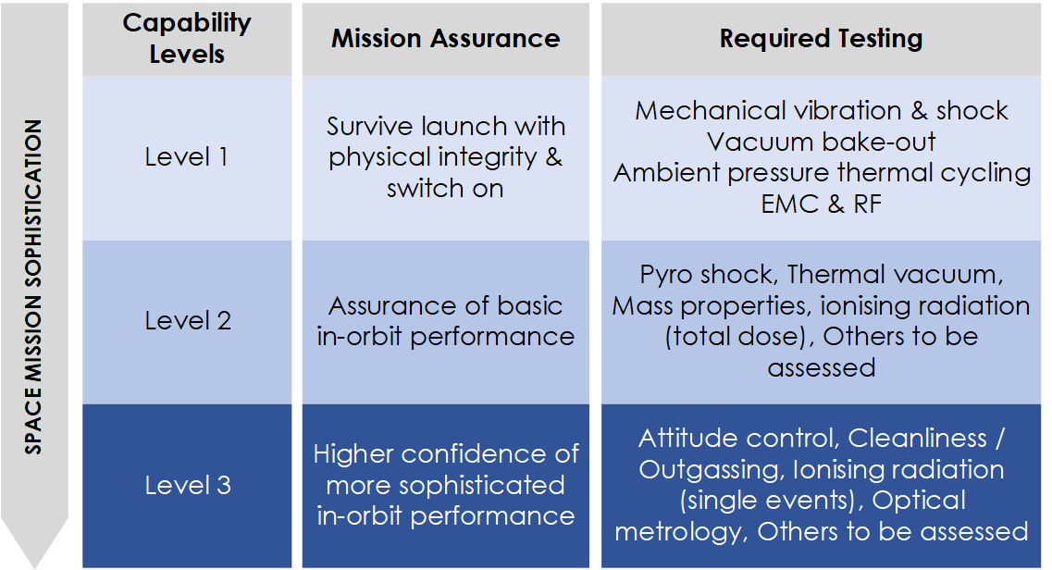

The audit found that:
- there is Level 1 qualification capacity in Australia, however improvement in awareness, availability, capability and accreditation will benefit the needs of the space sector
- there are gaps in Level 2 qualification capability and capacity in Australia which if filled, will support the growth and transformation of the Australian space sector
- Level 3 qualification capability and capacity is very limited in Australia and, at present, Level 3 qualification is usually accessed outside Australia. If filled, this could also support the growth and transformation of the Australian space sector.
The Space Payload Qualification Facilities grant opportunity will provide a single grant to build niche Level 2 or Level 3 capability. Through this investment, the project may also complement Level 1 facilities across Australia. We expect the capability developed to be self-sustaining after the grant period.
The objectives of the grant opportunity are to:
- increase space qualification capability and capacity in Australia
- improve the availability and coordination of space payload qualification in Australia
- increase accreditation and international recognition of space payload qualification in Australia
- meet the needs of the emerging space sector into the future.
The intended outcomes of the grant opportunity are:
- increased space payload qualification capability and capacity in Australia
- increased availability of space payload qualification facilities
- increased investment in Australian space industry
- increased Australian space industry capability.
We administer the program according to the Commonwealth Grants Rules and Guidelines (CGRGs).
This document sets out:
- the eligibility and assessment criteria
- how we consider and assess grant applications
- how we notify applicants and enter into grant agreements with grantees
- how we monitor and evaluate grantees’ performance
- responsibilities and expectations in relation to the opportunity.
The Department of Industry, Science, Energy and Resources (the department) is responsible for administering this grant opportunity.
We have defined key terms used in these guidelines in the glossary at section 14.
You should read this document carefully before you fill out an application.

Grant amount and grant period
The Australian Government has announced a total of $19.5 million over three years for the Space Infrastructure Program. Up to $2.5 million is available for this grant opportunity.

Grants available
There is a single grant of up to $2.5 million available under this grant opportunity.
The grant amount will be up to 75 per cent of project costs. You are responsible for the remaining 25 per cent of eligible project expenditure plus any ineligible expenditure.
You cannot use funding from other Commonwealth grants to fund your share of eligible project costs. You can fund your contribution from any other source including State, Territory and local government grants. Your contribution must be cash.

Project period
You must complete your project by 30 April 2022.

Eligibility criteria
We cannot consider your application if you do not satisfy all eligibility criteria.

Who is eligible?
To be eligible you must be one of the following entities:
- an entity incorporated in Australia and a trading corporation, where your trading activities
  - form a sufficiently significant proportion of the corporation’s overall activities as to merit it being described as a trading corporation; or
  - are a substantial and not merely peripheral activity of the corporation
- a publicly funded research organisation (PFRO) as defined in section 14.
Joint applications are acceptable and encouraged, provided you have a lead organisation who is the main driver of the project and is eligible to apply. For further information on joint applications, refer to section 7.2.

Additional eligibility requirements
We can only accept applications:
- where you can provide evidence from your board (or chief executive officer or equivalent if there is no board) that the project is supported, that you can complete the project and meet the costs of the project not covered by grant funding, and confirm you are a trading corporation.
We cannot waive the eligibility criteria under any circumstances.

Who is not eligible?
You are not eligible to apply if you are:
- an individual
- partnership
- unincorporated association
- any organisation not included in section 4.1
- trust (however, an incorporated trustee may apply on behalf of a trust)
- a non-corporate Commonwealth entity.

What the grant money can be used for

Eligible activities
The space payload qualification facility must be capable of supporting the following activities:
- building niche or unique Level 2 or Level 3 qualification capability and capacity in Australia
- support, cooperation and/or coordination across space payload qualification facilities and capabilities in Australia
- support that expands Australian space industry capability and capacity, for example:
  - research and development (R&D)
  - training
  - testing and validation
  - collaborative R&D.
Eligible activities may include:
- purchasing, upgrading and commissioning testing equipment
- marketing and communications activities to improve knowledge of and access to testing facilities by SMEs and researchers
- support the coordination across testing facilities across Australia
- preparing a functional design brief or equivalent
- purchasing hardware (screens, cables, furniture, antennas, fibre optic links, other ICT etc.) and software to run the required qualification tests
- hiring appropriate staff and contractors to fit-out and operate the facility
- managing the security requirements for the centre, including its public elements
- operating, managing and controlling the centre for the grant funding period
- establishing a financially self-sustaining operating model
- organising and managing training activities in conjunction with universities/schools.
We may also approve other activities where they directly relate to achieving project outcomes.

Eligible expenditure
You can only spend grant funds on eligible expenditure you have incurred on an agreed project as defined in your grant agreement.
Eligible expenditure items are:
- direct labour costs of employees you directly employ on the core elements of the project. We consider a person an employee when you pay them a regular salary or wage, out of which you make regular tax instalment deductions
- up to 30% labour on-costs to cover employer paid superannuation, payroll tax, workers compensation insurance, and overheads such as office rent and the provision of computers for staff directly working on the project
- contract expenditure, which is the cost of any agreed project activities that you contract to others
- capital expenditure for the purchase of assets directly related to the project
- building modifications, where the modification is necessary to undertake the project
- installation and commissioning costs
- marketing and communication costs
- staff training that directly supports the achievement of project outcomes
- domestic and overseas travel limited to the reasonable cost of accommodation and transportation required to conduct the agreed project and collaboration activities
- the cost of an independent audit of project expenditure up to a maximum of 1% of total eligible project expenditure. Projects with a total value over $500,000 (excluding GST) will be required to complete an independent audit
- other eligible expenditure as approved by the program delegate (who is an AusIndustry manager within the department with responsibility for the program).
Not all expenditure on your project may be eligible for grant funding. The program delegate makes the final decision on what is eligible expenditure and may give additional guidance on eligible expenditure if required.
To be eligible, expenditure must:
- be a direct cost of the project
- be incurred by you for required project audit activities.
You must incur the project expenditure between the project start and end date for it to be eligible.
You may elect to commence your project from the date we notify you that your application is successful. We are not responsible for any expenditure you incur until a grant agreement is executed. The Commonwealth will not be liable, and should not be held out as being liable, for any activities undertaken before the grant agreement is executed.

What you cannot use the grant for
Expenditure items that are not eligible include but are not limited to:
- business as usual expenses, or maintenance costs
- routine operational expenses, including communications, accommodation, office computing facilities, printing and stationery, postage, legal and accounting fees and bank charges, not directly related to the project
- non project-related costs, costs associated with ineligible activities, or any ongoing costs beyond the term of the grant
- costs of purchasing, leasing, depreciation of, or development of land
- research not directly supporting eligible activities
- non-project-related staff training and development costs
- licensing fees paid to Australian government bodies, for example the Australian Media and Communications Authority (ACMA)
- accreditation costs
- costs related to preparing the grant application, preparing any project reports (except costs of independent audit reports we require) and preparing any project variation requests.

The assessment criteria
You must address all assessment criteria in your application. We will assess your application based on the weighting given to each criterion.
The application form asks questions that relate to the assessment criteria below. The amount of detail and supporting evidence you provide in your application should be relative to the project size, complexity and grant amount requested. You should provide evidence to support your answers. The application form displays size limits for answers.
We will only consider funding applications that score at least 50 per cent against each assessment criterion, as these represent best value for money.

Assessment criterion 1
How your project will improve space payload qualification in Australia (40 points).
Describe your approach to improving Australian space payload qualification and provide information that demonstrates how your project will:
- increase niche and/or unique Level 2 or 3 qualification capacity and capability in Australia
- provide access and availability of niche and/or unique Level 2 and/or Level 3 qualification capability for the Australian and international space sector
- complement and coordinate with existing space payload qualification facilities in Australia.

Assessment criterion 2
Your capacity, capability and resources to deliver the project (30 points).
You should demonstrate this by describing:
- your track record in managing similar projects, including your access to relevant skills, experience, networks, infrastructure, technology and intellectual property
- your project plan, including your plan to:
  - manage the project including scope, implementation methodology and timeframes
  - mitigate cyber security and national security risks, including potential for foreign interference, in the establishment and on-going operations of the centre
  - secure required regulatory or other approvals.
- how your project meets international best practice for testing and/or qualification, including alignment with relevant standards or accreditations that may be achieved in the future
- your ability to meet the future needs of the space industry and provide financially sustainable space qualification services beyond the period of project funding.
You must make a strong case that you can effectively manage national security risk to be awarded funding.
You must attach a project plan and budget to your application. Template are available on business.gov.au and GrantConnect.

Assessment criterion 3
The impact of grant funding (30 points)
You should demonstrate this by describing:
- the need/demand and industry support for your project which could include, but not limited to, letters of support from the Australian or international space sector
- your need for funding and the value of the funding to your organisation
- the broader national value of your project, how it will benefit Australian space value chains, including spill over effects into other industry sectors, support for SMEs, growth of the economy and/or employment growth
- any additional investment or contributions your project will leverage, including support from State, Territory and/or local government.

How to apply
Before applying you should read and understand these guidelines, the sample application form and the sample grant agreement published on business.gov.au and GrantConnect.
To apply, you must:
- complete the online application form via business.gov.au
- provide all the information requested
- address all eligibility and assessment criteria
- include all necessary attachments.
You should retain a copy of your application for your own records.
You are responsible for making sure your application is complete and accurate. Giving false or misleading information is a serious offence under the Criminal Code Act 1995 (Cth). If we consider that you have provided false or misleading information we may not progress your application. If you find an error in your application after submitting it, you should call us immediately on 13 28 46.
If we find an error or information that is missing, we may ask for clarification or additional information from you that will not change the nature of your application. However, we can refuse to accept any additional information from you that would change your submission after the application closing time.
If you need further guidance around the application process, or if you are unable to submit an application online, contact us at business.gov.au or by calling 13 28 46.

Attachments to the application
You must provide the following documents with your application:
- project plan
- project budget
- evidence of support from the board, CEO or equivalent (template provided on business.gov.au and GrantConnect)
- trust deed (where applicable).
You may also provide the following attachments where relevant to your application:
- evidence of industry support.
You must attach supporting documentation with your application in line with the instructions provided within the form. You should only attach requested documents. We will not consider information in attachments that we do not request.

Joint applications
We recognise that some organisations may want to join together as a group to deliver a project. In these circumstances, you must appoint a lead organisation. Only the lead organisation can submit the application form and enter into the grant agreement with the Commonwealth. The application should identify all other members of the proposed group and include a letter of support from each of the project partners. Each letter of support should include:
- details of the project partner
- an overview of how the project partner will work with the lead organisation and any other project partners in the group to successfully complete the project
- an outline of the relevant experience and/or expertise the project partner will bring to the group
- the roles/responsibilities the project partner will undertake, and the resources it will contribute (if any)
- details of a nominated management level contact officer.

Timing of grant opportunity
You can only submit an application between the published opening and closing dates. We cannot accept late applications.
Table 1: Expected timing for this grant opportunity
Activity | Timeframe
Assessment of applications | 6 weeks
Approval of outcomes of selection process | 4 weeks
Negotiations and award of grant agreements | 4 weeks
Notification to unsuccessful applicants | 2 weeks
Earliest start date of grant activity | 01/04/2021
End date of grant commitment | 30/04/2022

The grant selection process
We first review your application against the eligibility criteria. If eligible, we will then assess it against the assessment criteria. Only eligible applications will proceed to the assessment stage.
We consider your application on its merits, based on:
- how well it meets the criteria
- how it compares to other applications
- whether it provides value with relevant money.
When assessing whether the application represents value with relevant money, we will have regard to:
- the overall objectives of the grant opportunity
- the evidence provided to demonstrate how your project contributes to meeting those objectives
- the relative value of the grant sought.
We will establish a committee that has government and industry and/or space sector experience, including members from the Australian Space Agency. The committee may also have external experts and may seek additional advice from independent technical experts. All committee members, including any expert or advisor who is not a Commonwealth Official, will be expected to perform their duties in accordance with the Commonwealth Grants Rules and Guidelines
The committee will assess your application against the assessment criteria and compare it to other eligible applications before recommending which projects to fund.
If the selection process identifies unintentional errors in your application, we may contact you to correct or clarify the errors, but you cannot make any material alteration or addition.

Who will approve grants?
The Head or Deputy Head of the Australian Space Agency decides which grant to approve taking into account the recommendations of the committee.
The Head or Deputy Head of the Australian Space Agency’s decision is final in all matters, including:
- the grant approval
- the grant funding to be awarded
- any conditions attached to the offer of grant funding.
We cannot review decisions about the merits of your application.
The Head or Deputy Head of the Australian Space Agency will not approve funding if there is insufficient program funds available across relevant financial years for the program.

Notification of application outcomes
We will advise you of the outcome of your application in writing. If you are successful, we advise you of any specific conditions attached to the grant.
If you are unsuccessful, we will give you an opportunity to discuss the outcome with us.

Successful grant applications

Grant agreement
You must enter into a legally binding grant agreement with the Commonwealth. We will use a Commonwealth simple grant agreement. The grant agreement has general terms and conditions that cannot be changed. A sample grant agreement is available on business.gov.au and GrantConnect.
We must execute a grant agreement with you before we can make any payments. Execute means both you and the Commonwealth have signed the agreement. We are not responsible for any expenditure you incur until a grant agreement is executed.
The approval of your grant may have specific conditions determined by the assessment process or other considerations made by the Head or Deputy Head of the Space Agency. We will identify these in the offer of grant funding.
If you enter an agreement under the Space Infrastructure Fund: Space Payload Qualification Facilities grant opportunity you cannot receive other grants for the same activities from other Commonwealth granting programs.
The Commonwealth may recover grant funds if there is a breach of the grant agreement.
You will have 30 days from the date of a written offer to execute this grant agreement with the Commonwealth. During this time, we will work with you to finalise details.
The offer may lapse if both parties do not sign the grant agreement within this time. Under certain circumstances, we may extend this period. We base the approval of your grant on the information you provide in your application. We will review any required changes to these details to ensure they do not impact the project as approved by the Head or Deputy Head of the Australian Space Agency.

Space Payload Qualification Facilities specific legislation, policies and industry standards
You must comply with all relevant laws and regulations in undertaking your project. You must also comply with the specific legislation/policies/industry standards that follow. It is a condition of the grant funding that you meet these requirements. We will include these requirements in your grant agreement.
In particular, you will be required to comply with:
- State/Territory legislation in relation to working with children
- Space (Launches and Returns) Act 2018 and associated rules including:
  - Space (Launches and Returns) (General) Rules 2019
  - Space (Launches and Returns) (Insurance) Rules 2019
  - Space (Launches and Returns) (High Power Rocket) Rules 2019
- Export control legislation including the Defence Trade Controls Act 2012 and Customs Act 1901
- Radiocommunications Act 1992
- any relevant international testing standards
- any relevant export control requirements
- any relevant national security requirements.

How we pay the grant
The grant agreement will state the:
- maximum grant amount we will pay
- proportion of eligible expenditure covered by the grant (grant percentage)
- any financial contribution provided by you or a third party.
We will not exceed the maximum grant amount under any circumstances. If you incur extra costs, you must meet them yourself.
We will make payments according to an agreed schedule set out in the grant agreement. Payments are subject to satisfactory progress on the project.

Tax obligations
We will add GST to your grant payment and provide you with a recipient created tax invoice. You are required to notify us if your GST registration status changes during the project period.
Grants are assessable income for taxation purposes, unless exempted by a taxation law. We recommend you seek independent professional advice on your taxation obligations or seek assistance from the Australian Taxation Office. We do not provide advice on tax.

Announcement of grants
We will publish non-sensitive details of successful projects on GrantConnect. We are required to do this by the Commonwealth Grants Rules and Guidelines unless otherwise prohibited by law. We may also publish this information on business.gov.au. This information may include:
- name of your organisation
- title of the project
- description of the project and its aims
- amount of grant funding awarded
- Australian Business Number
- business location
- your organisation’s industry sector.

How we monitor your grant activity

Keeping us informed
You should let us know if anything is likely to affect your project or organisation.
We need to know of any key changes to your organisation or its business activities, particularly if they affect your ability to complete your project, carry on business and pay debts due.
You must also inform us of any changes to your:
- name
- addresses
- nominated contact details
- bank account details.
If you become aware of a breach of terms and conditions under the grant agreement you must contact us immediately.
You must notify us of events relating to your project and provide an opportunity for the Minister or their representative to attend.
You can contact us at spacegrants@industry.gov.au or by calling 13 28 46.

Reporting
You must submit reports in line with the grant agreement. We will provide the requirements for these reports as appendices in the grant agreement. We will remind you of your reporting obligations before a report is due. We will expect you to report on:
- progress against agreed project milestones
- project expenditure, including expenditure of grant funds
- contributions of participants directly related to the project.
The amount of detail you provide in your reports should be relative to the project size, complexity and grant amount.
We will monitor the progress of your project by assessing reports you submit and may conduct site visits to confirm details of your reports if necessary. Occasionally we may need to re-examine claims, seek further information or request an independent audit of claims and payments.

Progress reports
Progress reports must:
- include details of your progress towards completion of agreed project activities
- show the total eligible expenditure incurred to date
- include evidence of expenditure
- be submitted by the report due date (you can submit reports ahead of time if you have completed relevant project activities).
We will only make grant payments when we receive satisfactory progress reports.
You must discuss any project or milestone reporting delays with us as soon as you become aware of them.

End of project report
When you complete the project, you must submit an end of project report.
End of project reports must:
- include the agreed evidence as specified in the grant agreement
- identify the total eligible expenditure incurred for the project
- include a declaration that the grant money was spent in accordance with the grant agreement and to report on any underspends of the grant money
- be submitted by the report due date.

Post project report
12 months after you complete the project, you must submit a post project report.
Post project reports provide an update on the outcomes of your project and allow us to gather information to support evaluation of the program.

Ad-hoc reports
We may ask you for ad-hoc reports on your project. This may be to provide an update on progress, or any significant delays or difficulties in completing the project.

Independent audits
We may ask you to provide an independent audit report. An audit report will verify that you spent the grant in accordance with the grant agreement. The audit report requires you to prepare a statement of grant income and expenditure. The report template is available on business.gov.au and GrantConnect.

Compliance visits
We may visit you during the project period to review your compliance with the grant agreement. We may also inspect the records you are required to keep under the grant agreement. We will provide you with reasonable notice of any compliance visit.

Grant agreement variations
We recognise that unexpected events may affect project progress. In these circumstances, you can request a variation to your grant agreement, including:
- changing project milestones
- changing project activities.
The program does not allow for:
- an increase of grant funds.
If you want to propose changes to the grant agreement, you must put them in writing before the project end date.
If a delay in the project causes milestone achievement and payment dates to move to a different financial year, you will need a variation to the grant agreement. We can only move funds between financial years if there is enough program funding in the relevant year to allow for the revised payment schedule. If we cannot move the funds, you may lose some grant funding.
You should not assume that a variation request will be successful. We will consider your request based on factors such as:
- how it affects the project outcome
- consistency with the program policy objective, grant opportunity guidelines and any relevant policies of the department
- changes to the timing of grant payments
- availability of program funds.

Evaluation
We will evaluate the grant opportunity to measure how well the outcomes and objectives have been achieved. We may use information from your application and project reports for this purpose. We may also interview you, or ask you for more information to help us understand how the grant impacted you and to evaluate how effective the program was in achieving its outcomes.
We may contact you up to two years after you finish your project for more information to assist with this evaluation.

Grant acknowledgement
If you make a public statement about a project funded under the program, including in a brochure or publication, you must acknowledge the grant by using the following:
‘This project received grant funding from the Australian Government.’
If you erect signage in relation to the project, the signage must contain an acknowledgement of the grant.

Probity
We will make sure that the grant opportunity process is fair, according to the published guidelines, incorporates appropriate safeguards against fraud, unlawful activities and other inappropriate conduct and is consistent with the CGRGs.

Conflicts of interest
Any conflicts of interest could affect the performance of the grant opportunity or program. There may be a conflict of interest, or perceived conflict of interest, if our staff, any member of a committee or advisor and/or you or any of your personnel:
- has a professional, commercial or personal relationship with a party who is able to influence the application selection process, such as an Australian Government officer or member of an external panel
- has a relationship with or interest in, an organisation, which is likely to interfere with or restrict the applicants from carrying out the proposed activities fairly and independently or
- has a relationship with, or interest in, an organisation from which they will receive personal gain because the organisation receives a grant under the grant program/ grant opportunity.
As part of your application, we will ask you to declare any perceived or existing conflicts of interests or confirm that, to the best of your knowledge, there is no conflict of interest.
If you later identify an actual, apparent, or perceived conflict of interest, you must inform us in writing immediately.
Conflicts of interest for Australian Government staff are handled as set out in the Australian Public Service Code of Conduct (Section 13(7)) of the Public Service Act 1999 (Cth). Committee members and other officials including the decision maker must also declare any conflicts of interest.
We publish our conflict of interest policy on the department’s website.

How we use your information
Unless the information you provide to us is:
- confidential information as per 13.2.1, or
- personal information as per 13.2.3,
we may share the information with other government agencies for a relevant Commonwealth purpose such as:
- to improve the effective administration, monitoring and evaluation of Australian Government programs
- for research
- to announce the awarding of grants.

How we handle your confidential information
We will treat the information you give us as sensitive and therefore confidential if it meets all of the following conditions:
- you clearly identify the information as confidential and explain why we should treat it as confidential
- the information is commercially sensitive
- disclosing the information would cause unreasonable harm to you or someone else
- you provide the information with an understanding that it will stay confidential.

When we may disclose confidential information
We may disclose confidential information:
- to the committee and our Commonwealth employees and contractors, to help us manage the program effectively
- to the Auditor-General, Ombudsman or Privacy Commissioner
- to the responsible Minister or Assistant Minister
- to a House or a Committee of the Australian Parliament.
We may also disclose confidential information if:
- we are required or authorised by law to disclose it
- you agree to the information being disclosed, or
- someone other than us has made the confidential information public.

How we use your personal information
We must treat your personal information according to the Australian Privacy Principles (APPs) and the Privacy Act 1988 (Cth). This includes letting you know:
- what personal information we collect
- why we collect your personal information
- to whom we give your personal information.
We may give the personal information we collect from you to our employees and contractors, the committee, and other Commonwealth employees and contractors, so we can:
- manage the program
- research, assess, monitor and analyse our programs and activities.
We, or the Minister, may:
- announce the names of successful applicants to the public
- publish personal information on the department’s websites.
You may read our Privacy Policy on the department’s website for more information on:
- what is personal information
- how we collect, use, disclose and store your personal information
- how you can access and correct your personal information.

Freedom of information
All documents in the possession of the Australian Government, including those about the program, are subject to the Freedom of Information Act 1982 (Cth) (FOI Act).
The purpose of the FOI Act is to give members of the public rights of access to information held by the Australian Government and its entities. Under the FOI Act, members of the public can seek access to documents held by the Australian Government. This right of access is limited only by the exceptions and exemptions necessary to protect essential public interests and private and business affairs of persons in respect of whom the information relates.
If someone requests a document under the FOI Act, we will release it (though we may need to consult with you and/or other parties first) unless it meets one of the exemptions set out in the FOI Act.

Enquiries and feedback
For further information or clarification, you can contact us on 13 28 46 or by web chat or through our online enquiry form on business.gov.au.
We may publish answers to your questions on our website as Frequently Asked Questions.
Our Customer Service Charter is available at business.gov.au. We use customer satisfaction surveys to improve our business operations and service.
If you have a complaint, call us on 13 28 46. We will refer your complaint to the appropriate manager.
If you are not satisfied with the way we handle your complaint, you can contact:
Head of Division
AusIndustry – Support for Business
Department of Industry, Science, Energy and Resources
GPO Box 2013
CANBERRA ACT 2601
You can also contact the Commonwealth Ombudsman with your complaint (call 1300 362 072). There is no fee for making a complaint, and the Ombudsman may conduct an independent investigation.

Glossary
Term | Definition
Application form | The document issued by the Program Delegate that applicants use to apply for funding under the program.
AusIndustry | The division of the same name within the department.
Department | The Department of Industry, Science, Energy and Resources.
Eligible activities | The activities undertaken by a grantee in relation to a project that are eligible for funding support as set out in 5.1.
Eligible application | An application or proposal for grant funding under the program that the Program Delegate has determined is eligible for assessment in accordance with these guidelines.
Eligible expenditure | The expenditure incurred by a grantee on a project and which is eligible for funding support as set out in 5.2.
Grant agreement | A legally binding contract between the Commonwealth and a grantee for the grant funding.
Grant funding or grant funds | The funding made available by the Commonwealth to grantees under the program.
GrantConnect | The Australian Government’s whole-of-government grants information system, which centralises the publication and reporting of Commonwealth grants in accordance with the CGRGs.
Grantee | The recipient of grant funding under a grant agreement.
Guidelines | Guidelines that the Minister gives to the department to provide the framework for the administration of the program, as in force from time to time.
Minister | The Commonwealth Minister for Industry, Science and Technology.
Level 1 testing | Tests conducted to ensure the space mission will survive launch with physical integrity and ability to switch on.
Level 2 testing | Tests conducted to assure basic in-orbit performance.
Level 3 testing | Tests conducted to provide higher confidence of more sophisticated in-orbit performance.
Non-income-tax-exempt | Not exempt from income tax under Division 50 of the Income Tax Assessment Act 1997 (Cth) or under Division 1AB of Part III of the Income Tax Assessment Act 1936 (Cth).
Personal information | Has the same meaning as in the Privacy Act 1988 (Cth) which is:  Information or an opinion about an identified individual, or an individual who is reasonably identifiable:  - whether the information or opinion is true or not; and  - whether the information or opinion is recorded in a material form or not.
Program Delegate | An AusIndustry manager within the department with responsibility for the program.
Program funding or Program funds | The funding made available by the Commonwealth for the program.
Project | A project described in an application for grant funding under the program.
Publicly funded research organisation (PFRO) | All higher education providers listed at Table A and Table B of the Higher Education Support Act 2003 (Cth) and corporate Commonwealth entities, and State and Territory business enterprises which undertake publicly funded research.

NB. A technical glossary is provided as an annex to Appendix A

Appendix A
National Payload Qualification Facility Audit
Executive Summary
Conducted by Nova Systems – Complex Communications and Space – on behalf of the Australian Space Agency
September 2020

How can space infrastructure investment enhance the national space payload qualification capability to best meet current and future needs and opportunities?
A survey of the existing space qualification test capability in Australia has examined current usage and has canvassed its future needs. These insights, coupled with Nova Systems’ expert knowledge of space technology testing and the space business, have been provided to inform the Australian Space Agency as it considers how best to support growth and transformation of Australia’s space sector via investment in test infrastructure. This summary reflects a limited, public domain subset of this information to inform Australia’s space industry.
Contents
Introduction………………………………………………………………………………………………….24
The Australian Space Sector……..………………………………………………………………………25
Existing Capacity…………………………………………………………………………...………………26
Potential Demand for Testing…………………………………………………………………………….27
Gaps in Capability Testing ………………………………………………………………………………28
Conclusions………………………………………………………………………………………………….30
Annex – Directory of Australian Space Test Capability………………………………………….….31
Disclaimer: This report has been prepared by Nova Systems following a detailed analysis of the space sector and the results of the related survey conducted from March to August 2020. The contents, conclusions and recommendations of this report are independently delivered by Nova Systems and may not necessarily reflect the view of the Australian Space Agency.

Introduction
There are two main purposes to the testing used in qualifying payloads for space. The first is to satisfy the launch provider that the payload will not cause harm to the launch vehicle or its other payloads (for example, by breaking during launch). The second is to verify to the payload owner that it will survive and function as intended in the environment on orbit.
The survey revealed that currently in Australia the mandatory tests required by launch providers for small satellites, in particular those of the CubeSat class, can be carried out. Certain gaps do exist in this capability, but at the detailed level: for example, in the specific performance of a test facility, or in the availability of instrumentation at the test site. Importantly, the survey has highlighted a gap in the space testing skills and expertise available in Australia and a need for education about the benefits of a standards-based approach to testing.
The survey also showed that space payload development activity in Australia is dominated by CubeSat projects and is likely to remain so for the medium term. Nova estimates that a significant growth in demand could comfortably be accommodated by the present infrastructure. Figure 1 summarises the space testing situation in Australia in 2020.
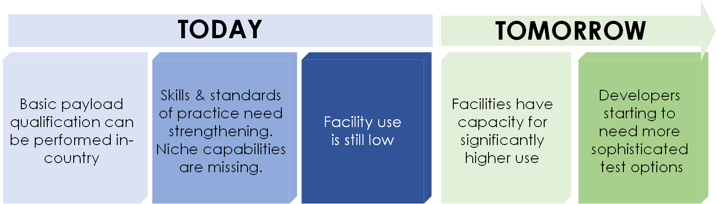
Figure 1 A Snapshot of Space Testing in Australia Today
There could be strategic advantages in investing to increase the national test capability beyond that of launch qualification and basic performance checks. This could include the ability to develop more sophisticated payloads and a higher level of mission assurance, which would raise quality and sector competitiveness globally.

The Australian Space Sector
A space payload has been defined by the Agency for the purposes of this audit as “any system, subsystem, assembly, instrument or component that is intended for launch into space”. While space sector activity in Australia also extends to launch vehicles, bio-medical research and high altitude platforms, in terms of the number of active organisations – at 77% - it is dominated by orbital payload developments.
The testing requirements of each area of activity are quite different. This audit covered them all, but focused especially on orbital payload development, because this activity requires the facilities to qualify hardware for space. Since the majority of organisations work in this area, they will likely influence the growth of the sector. Most of these are research organisations, rather than commercial entities. Figure 2 shows the composition and distribution of the Australian space sector.
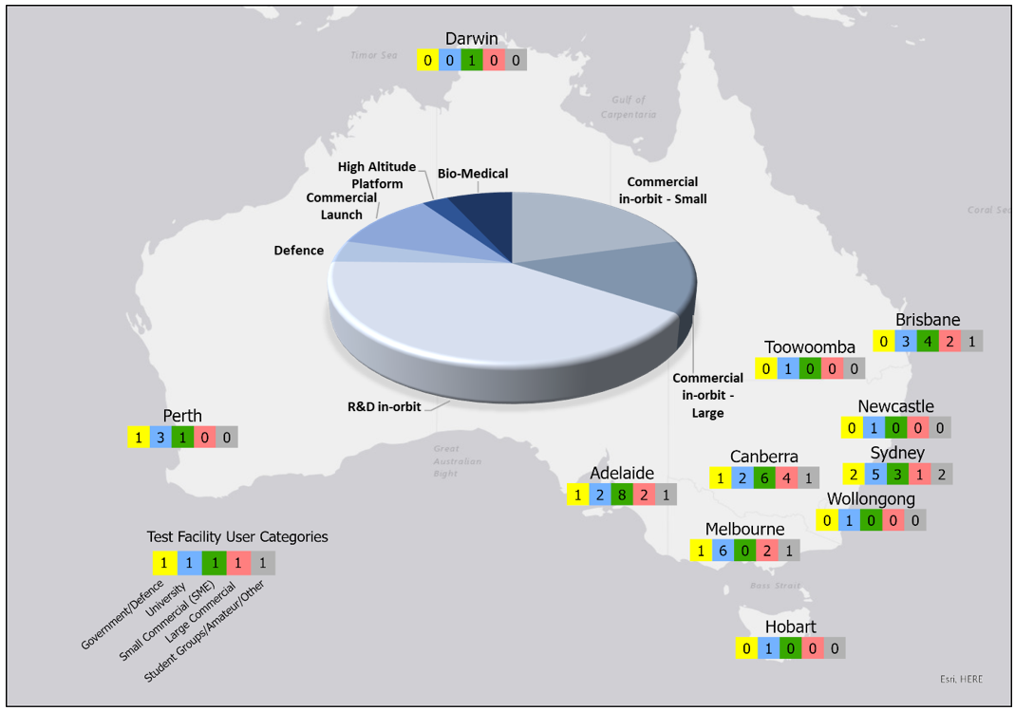
Figure 2 Distribution of Organisation Types in the Australian Space Sector.
Figure 3 depicts payload testing types and their purposes.

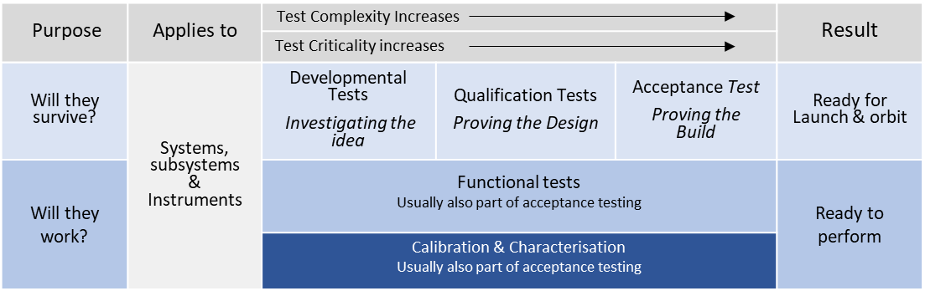
Figure 3 A classification of payload types of tests

Existing Capability
Nova Systems has divided space payload test capability into three tiers of sophistication (Levels 1 to 3, shown in Figure 4). This facilitates benchmarking the current status and mapping out a growth path relative to sector needs. Level 1 covers the mandatory testing required for launch as a secondary payload - the case for all CubeSats and most small satellites – plus basic thermal cycling, radio frequency measurement and electromagnetic characterisation, which will provide a minimum check of on-orbit performance. Levels 2 and 3 cover more sophisticated tests which lead to greater mission assurance. Figure 5 shows how Level 1 test capability is already present in many of the state capitals.

Figure 4 Test capability classification
The annex to this report contains a comprehensive list of facilities in Australia which are relevant, or potentially relevant, to the qualification of space payloads.

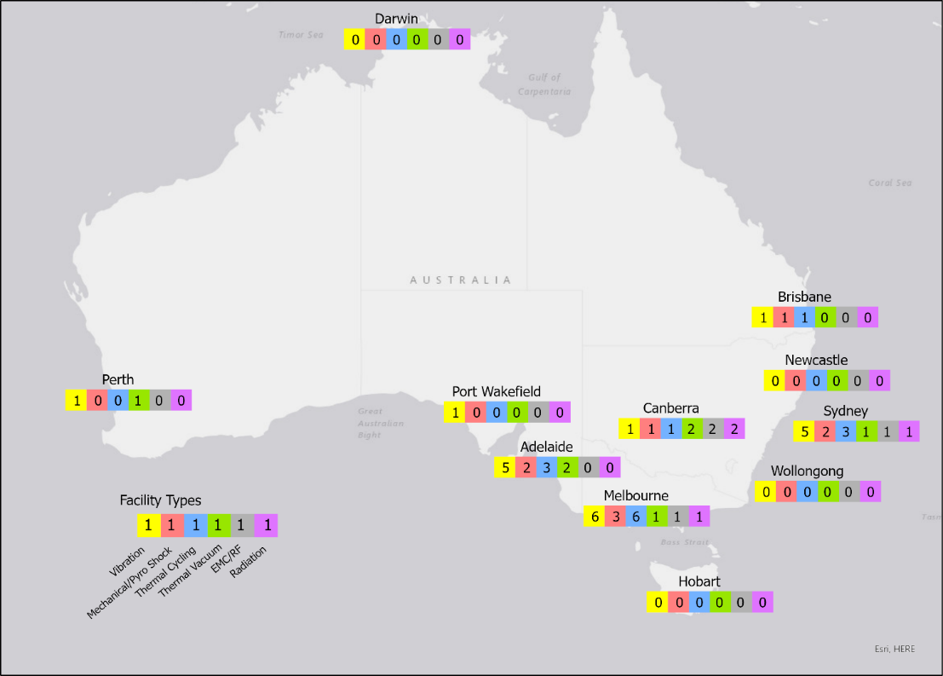
- Figure 5 Current distribution of basic test capability in Australia

Potential Demand for Testing
An overall response rate of 46% was obtained for the survey conducted in Q2 2020. Table 1 shows the survey statistics.
 | Approached | Responded | Response Rate
Australian test facility operators | 74 | 37 | 50%
Australian space technology developers | 75 | 32 | 43%
Total | 149 | 69 | 46%
Table 1 Survey statistics: organisations approached and organisations who responded
In terms of the different types of organisations within Australia, the survey obtained the following picture of testing needs across the nation:
Small commercial companies developing in-orbit payloads:
- The majority of testing comprises mandatory pre-launch qualifications
- Several organisations are procuring satellites already fully tested from overseas
- Others intend to use facilities in Adelaide and at the Advanced Instrumentation Technology Centre (AITC) in Canberra

Large commercial companies developing in-orbit payloads (mainly overseas primes):
- No current needs declared, but if they arose, they would use facilities at Defence Science and Technology Group (DSTG) located at Edinburgh, SA, the AITC located at Canberra or overseas at their parent companies

R&D organisations developing in-orbit payloads:
- Several organisations are actively developing in-house test capability to meet their developmental testing needs
- Most identify the AITC in Canberra for final pre-launch qualification testing

Defence Space Sector:
- DSTG is expanding its own testing capability, but views the AITC in Canberra as a strategic national asset
- Other areas in Defence identified a need to create a more coherent capability with the existing infrastructure, and to improve the quality of testing practices

Orbital payload development is the largest sector by numbers. Almost all require the core qualification tests for launch: mechanical vibration, mechanical shock and thermal vacuum. Most desire electromagnetic interference/compatibility testing (EMI/EMC) and some means of verifying their radiofrequency (RF) communications subsystems. A handful plan more comprehensive functional testing of their systems (i.e. verifying software and controls).
Commercial Launch Sector:
- Demand and needs varied across the sector according to aims: those focussing on orbital launch had the greatest demand for testing infrastructure
- Locations are needed for dangerous activities (e.g. engine firing, pressure testing)
- Two companies also plan to develop payloads and would use the AITC in Canberra

Test requirements range from: access to test cells for engine development and pressure testing facilities to verify pressurised fluid systems; means to balance rockets and payloads; wind tunnels for aerodynamic characterisation; mechanical test devices and RF/EMC test facilities; hardware-in-the-loop and sites to conduct test launches.
High Altitude Balloons:
- No responses received: no obvious demand for testing services from the sector

These platforms should be viewed as test facilities themselves. In some cases, environmental chambers (giving low pressure and temperature) would be used to test payloads prior to flight on these platforms. Access to airspace is required.
Bio-Medical Sector:
- Some radiation and microgravity testing (small samples) can be covered by existing facilities (ANU, ANSTO, CSIRO, University of Technology Sydney)

Organisations mentioned the need for access to simulated microgravity (e.g. by centrifuge, random positioning machine or parabolic flight aircraft), as well as to radiation sources to apply doses representative of conditions in space (e.g. using proton beams). Desert analogues and head-down bed rest laboratories for behavioural testing on humans were also mentioned.

Gaps in Test Capability
There are four types of gap in the national payload test capability:
- Minor infrastructure elements needed to complete Level 1 capability in some regions
- Key elements of a Level 2 capability for the nation
- Skills, expertise and education on the use of a recognised testing standard
- Niche capabilities identified as desirable by individual organisations in the sector.

The first relates to cases where organisations have the necessary test facility, but lack, for example, measurement instruments, mounting jigs or cleanliness suitable for space hardware, or adequate size. In a small number of cases, a certain type of test facility may be missing from a Level 1 complement (e.g. a thermal cycling chamber).
Secondly, there are gaps in capability which would be beneficial to fill to increase sector sophistication, quality and mission assurance. Research shows that such facilities would be used; however, the level of use is unlikely to sustain them independently.
Thirdly, the sector would benefit from access to skills and expertise in space testing. This would particularly help start-ups and universities as well as being of universal benefit to the national space sector. Several organisations raised this point in their survey responses. Currently, no standard is universally applied to space testing in Australia.
Finally, in their responses to the survey, organisations listed those test facilities they considered desirable. Figure 6 shows the relative popularity of a range of facilities currently unavailable and considered useful by different organisations. Here again, the level of use is likely to be low and sporadic and commercially unsustainable in the foreseeable future.

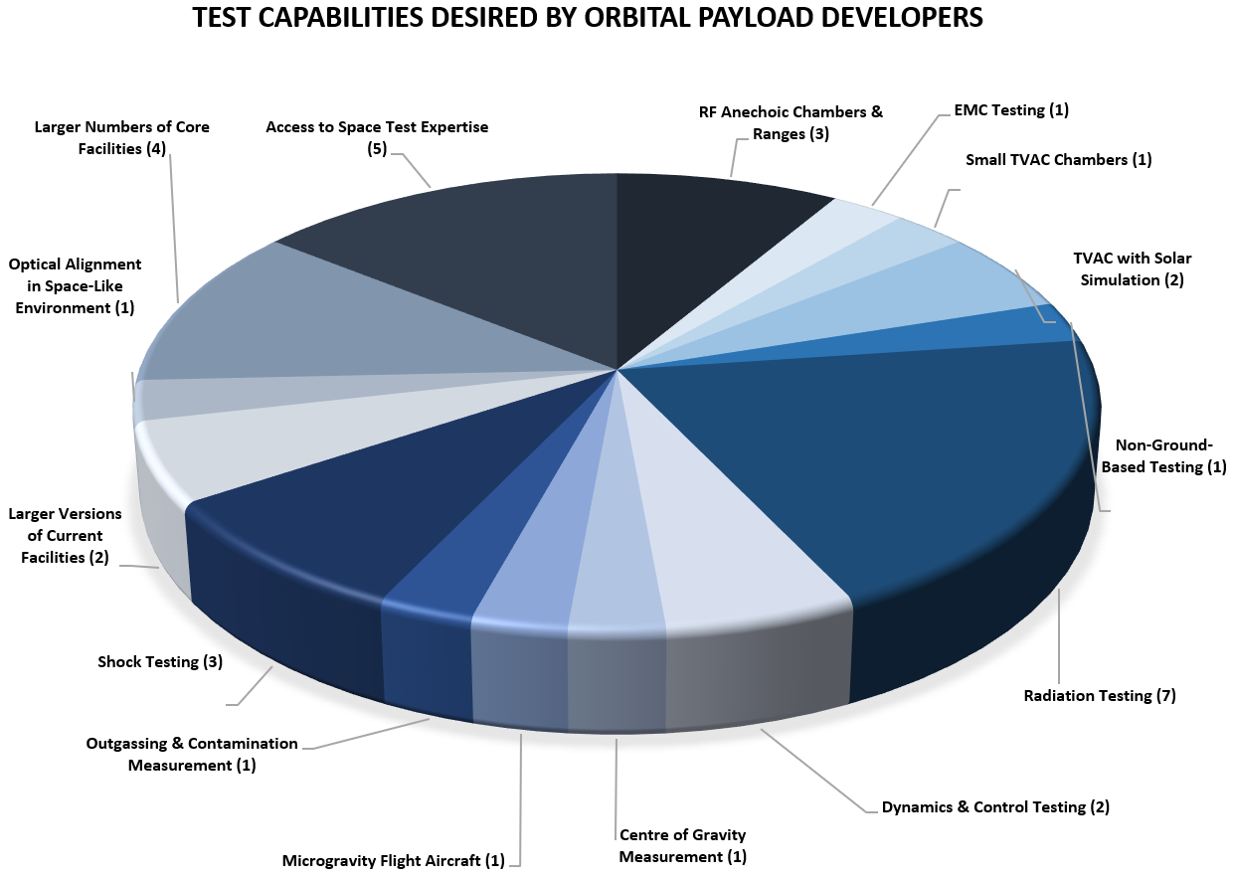
Figure 6 Numbers of organisation identifying different missing test capabilities

Conclusions
- Most infrastructure for Level 1 capability exists in multiple locations in Australia
- This allows the mandatory tests required by launch providers for auxiliary payloads to be performed
- Growth in demand for Level 1 testing can easily be accommodated for the foreseeable future
- Awareness in the sector of where the Level 1 capability exists needs to be raised: the attached annex contributes to this
- The Level 1 facilities would benefit from upgrades and enhancements: this could be co-ordinated by a national body
- There are gaps in Level 2 and 3 test capabilities which would enable greater mission assurance – and hence quality – to be achieved
- Uplifting national testing capability to Level 2 and 3 will also increase the competitiveness of the sector
- Supporting skills and expertise would enhance the sector’s performance
- Having reach-back to a national pool of space testing expertise would support reliable growth of the sector
- The current distribution of basic test facilities around the country facilitates a relatively straight-forward capability consolidation in centres where demand is highest
- There are nascent Level 2/3 test facilities in a small number of locations, upon which national capabilities could be built

Abbreviation | Meaning | Abbreviation | Meaning
AITC | Advanced Instrumentation Technology Centre | EMC | Electromagnetic Capability
ANSTO | Australian Nuclear Science and Technology Organisation | EMI | Electromagnetic Interference
ANU | Australia National University | RF | Radio Frequency
CSIRO | Commonwealth Scientific and Industrial Research Organisation | SA | South Australia
DSTG | Defence Science and Technology Group | TVAC | Thermal Vacuum

Annex – Directory of Australian Space Test Capability

Current and Potentially Relevant Payload Qualification Equipment in Australia

Notes:
- This annex contains the results of the audit of existing test capability.
- Whilst the audit may not be exhaustive, it provides the fullest overview currently available, based on the survey responses and follow-up investigations by Nova Systems.
- It is a directory of space payload qualification-relevant test facilities in Australia in May 2020
- It does not comment on the immediate suitability.
  - For example, modifications may be required when testing space hardware (eg the facility may not be sufficiently clean because of items tested previously, or suitable measurement equipment may not be available, or would need to be supplied by the user, or suitable mounting fixtures may not be available).
- The focus is largely on facilities for supporting qualification of orbital payloads, since this is the largest area of hardware development activity in the Australian space sector.
- For organisations which did not respond to the survey, publicly available information (for example, from company websites) was used as input.
- The tables reflect the existence of equipment, not necessarily the overall facility capability required to provide a fully effective test service.

Abbreviation | Meaning | Abbreviation | Meaning
CoG | Centre of Gravity | RGA | Residual Gas Analyser
DAQ | Data Acquisition | RH | Relative Humidity
GN2 | Gaseous Nitrogen | SRS | Shock Response Spectrum
HAB | High Altitude Balloon | TC | Thermal Cycling
LSP | Launch Service Provider | TQCM | Thermoelectric Quartz Crystal Microbalance
MoI | Moment of Inertia | TVAC | Thermal Vacuum
RF | Radio Frequency | UAV | Unmanned Aerial Vehicle

Class | Test | Identified Facilities | Facility Capability
Vibration tests | - Swept sine response search survey  - Modal survey  - Sinusoidal vibration  - Random Motion Vibration | - APC Technology, Cheltenham, SA | - Hardware developer with facilities for in-house testing not generally available to external users  - 10kN, slip table assumed
 |  | - APV-T Test Centre, Campbellfield VIC | - Commercial crash test lab  - 35kN, no slip table
 |  | - Austest Laboratories, Castle Hill, NSW | - Commercial test facility  - 5-off shakers with slip tables across three sites  - Largest 60kN
 |  | - Austest Laboratories, Reservoir VIC
 |  | - Austest Laboratories, Para Hills West, SA
 |  | - ANU AITC, Canberra ACT | - Test facility established for space testing  - 22kN shaker with slip table  - 450N shaker  - several rail-rider and tab-clamp CubeSat test fixtures available  - laboratory environment
 |  | - BAE Systems, Edinburgh SA | - In-house engineering test facility  - 22kN shaker with slip table  - 53kN shaker with slip table
 |  | - Bellinger Systems, Rydalmere NSW | - 110N shaker with limited instrumentation  - Component-level testing only
 |  | - Boeing Australia, Brisbane City QLD | - In-house engineering test facility – available to external customers  - shaker with slip table capacity not provided
 |  | - Boeing Australia, Port Melbourne VIC | - Facility supporting in-house testing In-house engineering test facility – no longer available to external customers  - 90kN shaker with slip table

Class | Test | Identified Facilities | Facility Capability
Vibration tests | - Swept sine response search survey  - Modal survey  - Sinusoidal vibration  - Random Motion Vibration | - Compliance Engineering, Keysborough VIC | - Commercial test facility  - 10kN with slip table
 |  | - Curtin University, Bentley WA | - Research laboratory; space hardware developer  - Facility details not provided in response
 |  | - DSTG, Edinburgh SA | - Research group developing space payloads  - Small 2.9kN shaker with basic instrumentation  - Slip table details not provided in response
 |  | - DST, Port Wakefield SA | - Known to have extensive facilities  - Facility details not provided
 |  | - Flight Data Systems, Keilor Park VIC | - Military/Civil aircraft equipment supplier with in-house test capability  - 29.6 kN with slip table  - Lab environment
 |  | - Uni of Adelaide, AVT | - Research laboratory; space hardware developer  - Facility details not provided in response
 |  | - Flight Data Systems, Keilor Park VIC | - Military/Civil aircraft equipment supplier with in-house test capability  - 29.6 kN with slip table  - Lab environment
 |  | - University of NSW Sydney ACSER, Sydney NSW | - Research laboratory; space hardware developer  - Small shaker facility planned
 |  | - University of Technology Sydney, Ultimo NSW | - Research laboratory  - Several shakers identified  - Facility details not provided in response
 |  | - Vipac Engineers & Scientists, Port Melbourne VIC | - Commercial test house catering to industry and defence  - New 60kN with slip table  - Old 22kN shaker with slip table  - laboratory environment
 |  | - Vipac Engineers & Scientists, Chester Hill NSW | - Commercial test house catering to industry and defence  - 10kN shaker with slip table  - 26kN shaker with slip table  - laboratory environment

Class | Test | Identified Facilities | Facility Capability
Shock Tests - Mechanical | - Mechanical Shock  - Launch environment loads  - Generally, not required for secondary payloads, but some LSPs do require it (e.g. Antrix PSLV)  - Commercial machines available for MIL-STD “bump” testing (low energy, large displacement)  - Shakers may also be used, depending on test level and test item mass | - APC Technology, Cheltenham, SA | - Hardware developer with facilities for in-house testing not generally available to external users  - Facility details not provided
 |  | - APV-T Test Centre, Campbellfield VIC | - Commercial crash test lab  - Facility details not provided
 |  | - Austest Laboratories, Castle Hill, NSW | - Commercial test facility  - equipment across three sites  - 1150kg capacity, <600g  - 100kg, <30000g
 |  | - Austest Laboratories, Reservoir VIC
 |  | - Austest Laboratories, Para Hills West, SA
 |  | - ANU AITC, Canberra ACT | - Test facility established for space testing  - 25kg bump test machine  - Laboratory environment  - Facility currently non-operational
 |  | - Boeing Australia, Brisbane City QLD | - In-house engineering test facility – available to external customers
 |  | - Vipac Engineers & Scientists, Port Melbourne VIC | - Commercial test house catering to industry and defence  - Facilities spread across sites  - 20,000g, 0.2 to 43ms half sine, <50kg, 300mm table  - 2,000g, 1 to 20ms half sine, <120kg, 500mm table  - 350g, 1 to 30ms half sine, <900kg, 1000mm table

Class | Test | Identified Facilities | Facility Capability
Shock Tests - Pyro | - Pyro Shock  - Launch environment loads – e.g. booster separation, fairing deployment, (large) spacecraft separation  - Only occasionally a requirement for secondary payloads (e.g. SpaceX Falcon 9, ULA Delta 2)  - Requires dedicated Shock Response Spectrum (SRS) facility and expertise to operate | - ANU AITC, Canberra | - Test facility established for space testing  - Resonant plate, nail-gun activated rig capable of 4000g SRS  - Laboratory environment  - Successfully used for BRMM CubeSat testing (with US collaborator support), but currently non-operational.  - Will require high-speed DAQ system and SRS software, as well as a significant investment in labour to understand SRS testing and “test formulas”
 |  | - Austest Laboratories, Castle Hill, NSW | - Commercial test facility  - Facility will need to be upgraded for high-frequency SRS testing.  - Facility details not provided

Class |  | Test | Identified Facilities | Facility Capability
Static load tests | - Structural integrity/strength test covering launch acceleration  - Required by LSPs on most spacecraft  - May be replaced by Quasi-static load (QSL) test on shakers at lowest possible frequency  - May be undertaken with a centrifuge |  | - Refer to vibration facilities for QSL capabilities
 |  |  | - Flight Data Systems, Keilor Park VIC | - Military/Civil aircraft equipment supplier with in-house test capability  - Centrifuge 20kg; ~500mm3; 17-21G  - Lab environment
Acoustic tests | - Acoustic vibration  - Covers acoustic environment inside LV fairing  - Generally, not applicable to small, secondary payloads  - Thus, not relevant in Australia at the present time  - Requires a reverberant chamber (building) |  | - Uni of Adelaide AVC | - Two reverberant chambers for acoustic fatigue of aircraft panels  - Suitability for spacecraft acoustic tests not determined  - Facility details not provided in response
 |  |  | - University of Technology Sydney, Ultimo NSW | - Reverberant chambers identified  - Suitability for spacecraft acoustic tests not determined  - Facility details not provided in response

Class | Test | Identified Facilities | Facility Capability
Mass properties tests | - Mass  - Centre of Gravity (CoG)  - Moment of Inertia (MoI)  - Spin balancing  - Launch providers generally require this information, but are satisfied with analysis | - ANU AITC, Canberra ACT | - Test facility established for space testing  - 25kg capacity CoG & MoI  - Class 10k cleanroom environment.  - Caters to CubeSat class spacecraft only

Class | Test | Identified Facilities | Facility Capability
Thermal Cycling (ambient pressure) | - Not required by LSPs, but this is an extremely useful facility for space hardware development and qualification test for electronics and deployable mechanisms.  - Chambers readily commercially available for -30°C to +80°C  - Must ensure that the facility has capability of 0% humidity (GN2 environment) to ensure no condensation/damage  - Climatic chambers may NOT be suitable (due to a lack of humidity control or inability to maintain 0%RH). | - APV-T Test Centre, Campbellfield VIC | - Commercial crash test lab  - Facility details not provided
 |  | - Austest Laboratories, Castle Hill, NSW | - Commercial test facility  - 15+ chambers across three sites  - -100°C to +120°C
 |  | - Austest Laboratories, Reservoir VIC
 |  | - Austest Laboratories, Para Hills West, SA
 |  | - ANU AITC, Canberra ACT | - Test facility established for space testing  - 1m³ GN2 purged chamber; -70°C to +120°C  - Currently not reliable – stops cooling  - Laboratory environment
 |  | - BAE Systems, Edinburgh SA | - In-house engineering test facility  - 8ft³ chamber: -68°C to +177°C  - 32ft³ chamber: -73°C to +177°C  - 0% RH details not provided in response
 |  | - Bellinger Systems, Rydalmere NSW | - Test facility serving defence  - 0,5m³ chamber. -0°C to +100°C  - 0% RH details not provided in response

Class | Test | Identified Facilities | Facility Capability
Thermal Cycling (ambient pressure) | - Not required by LSPs, but this is an extremely useful facility for space hardware development and qualification test for electronics and deployable mechanisms.  - Chambers readily commercially available for -30°C to +80°C  - Must ensure that the facility has capability of 0% humidity (GN2 environment) to ensure no condensation/damage  - Climatic chambers may NOT be suitable (due to a lack of humidity control or inability to maintain 0%RH). | - Boeing Australia, Brisbane City QLD | - In-house engineering test facility – available to external customers  - -40°C to +80°C  - -70°C to +180°C  - Chamber size and 0% RH details not provided in response
 |  | - Compliance Engineering, Keysborough VIC | - Commercial test facility  - -40°C to +180°C  - Chamber size and 0% RH details not provided in response
 |  | - DSTG, Edinburgh SA | - Research group developing space payloads -40°C to +180°C  - Chamber size and 0% RH details not provided in response
 |  | - DSTG, Fisherman’s Bend VIC | - Research group developing space payloads  - -80°C to +300°C; 10-80% RH  - Chamber size and 0% RH details not provided in response

Class | Test | Identified Facilities | Facility Capability
Thermal Cycling (ambient pressure) | - Not required by LSPs, but this is an extremely useful facility for space hardware development and qualification test for electronics and deployable mechanisms.  - Chambers readily commercially available for -30°C to +80°C  - Must ensure that the facility has capability of 0% humidity (GN2 environment) to ensure no condensation/damage  - Climatic chambers may NOT be suitable (due to a lack of humidity control or inability to maintain 0%RH). | - EMC Technologies, Melbourne | - Commercial test facility  - -70°C to 180°C  - Chamber size and 0% RH details not provided
 |  | - Flight Data Systems, Keilor Park VIC | - Military/Civil aircraft equipment supplier with in-house test capability  - -68°C to 180°C; 16 x 11 x 11.75  - -68°C to 180°C; 76cm3; 10% to 98% RH  - Lab environment
 |  | - University of Melbourne, Parkville VIC | - Research laboratory; space hardware developer  - -40°C to 90°C  - Chamber size and 0% RH details not provided in response
 |  | - Vipac Engineers & Scientists, Port Melbourne VIC | - Commercial test facility  - Several chambers up to walk-in size  - 1m3 chamber: 1-70°C to +180°C; ramp rates: >6°C/min; 0%RH (-20°C dewpoint)
 |  | - Vipac Engineers & Scientists, Chester Hill NSW | - Commercial test facility  - 1m3 chamber: -40°C to +180°C; 1.5m3; requires upgrade for dehumidification

Class | Test | Identified Facilities | Facility Capability
Thermal Cycling (high altitude – low pressure) | - Not required by LSPs  - Useful for high-altitude payloads (e.g. HABs, UAVs, sounding rocket payloads))  - This is a specialist test facility for high-altitude payloads, rather than space  - Commercial chambers exist (aircraft industry)  - TVAC and TC chambers not suitable due to the need to maintain stable (high-altitude) pressure  - Must ensure that the facility has capability of 0% humidity (GN2 environment) to ensure no condensation/damage | - Austest Laboratories, Castle Hill, NSW | - Commercial test facility  - 6 altitude chambers, up to 4.2 m3 across sites  - Max. altitude of 90,000 f
 |  | - Austest Laboratories, Reservoir VIC
 |  | - Austest Laboratories, Para Hills West, SA
 |  | - BAE Systems, Edinburgh SA | - In-house engineering test facility  - Altitude chamber; -50°C to +60°C; 70000ft; 680mm diameter x 780mm long
 |  | - Vipac Engineers & Scientists, Port Melbourne VIC | - Commercial test facility  - Altitude chamber of various sizes without thermal capability; 750000ft  - Chamber size not provided in response

Class | Test | Identified Facilities | Facility Capability
Thermal Vacuum (TVAC) | - Not required by LSPs (except for bakeout)  - High-vacuum chambers with dry (clean) pumping systems preferred  - Independently controlled thermal shrouds and platen required  - Operational temperature range depends on heating/cooling type  - Vacuum feedthroughs required for external services (e.g. power, data, RF comms, GPS etc)  - Ability for test item to operate from ground (external) power highly desirable  - It is critical that TVAC facilities have dry (oil-free) pumping systems for optical testing. Cryo & turbo pumping systems preferred.  - Thermal fluid leaks may cause catastrophic contamination. Clean thermal control such as gaseous or liquid nitrogen are non-contaminating.  - Existing facilities should be upgraded with contamination monitoring (eg TQCMs, RGAs) | - ANU AITC, Canberra ACT | - Custom 3m dia x 3m chamber  - Independent shroud & platen control  - Clean pumping & thermal control system  - -150°C to +150°C; <1E-7 torr  - Cryo-capture system; RGA; no TQCM  - Laboratory environment
 |  | - Curtin University, Perth | - Research laboratory; space hardware developer  - 45-180C; 7.5 E-7 torr  - Custom chamber  - Facility details (chamber size; shroud/platen; pumping & thermal control system) not provided in response  - Laboratory environment
 |  | - DSTG, Edinburgh SA | - Research group developing space payloads  - Custom Australian made chamber in fabrication  - Ø900 x 1000mm internal dimensions  - Independent shroud & platen control  - Clean pumping & thermal control system  - -150°C to +150°C; <1E-6 torr  - RGA; TQCM  - Cryo-capture system capability not provided in response

Class | Test | Identified Facilities | Facility Capability
Thermal Vacuum (TVAC) | - Not required by LSPs (except for bakeout)  - High-vacuum chambers with dry (clean) pumping systems preferred  - Independently controlled thermal shrouds and platen required  - Operational temperature range depends on heating/cooling type  - Vacuum feedthroughs required for external services (e.g. power, data, RF comms, GPS etc)  - Ability for test item to operate from ground (external) power highly desirable  - It is critical that TVAC facilities have dry (oil-free) pumping systems for optical testing. Cryo & turbo pumping systems preferred.  - Thermal fluid leaks may cause catastrophic contamination. Clean thermal control such as gaseous or liquid nitrogen are non-contaminating.  - Existing facilities should be upgraded with contamination monitoring (eg TQCMs, RGAs) | - Inovor Technologies, Adelaide SA | - SME developing spacecraft systems  - Fully utilised for in-housework, not necessarily available to external users  - Custom chamber (Scitek Australia)  - Internal thermal shroud only, platen (cold mounting plate) not driven; clean pumping system  - 350 x 500 x 800mm; 50kg  - -30 to +125C; 7.5 E-7 torr  - Office environment
 |  | - University of Melbourne, Parkville VIC | - Research group developing spacecraft systems  - Custom chamber: -2°C to +40°C; <1E-6 torr  - Facility details (chamber size; shroud/platen; pumping & thermal control system) not provided in response

Class | Test | Identified Facilities | Facility Capability
Thermal Vacuum (TVAC) | - Not required by LSPs (except for bakeout)  - High-vacuum chambers with dry (clean) pumping systems preferred  - Independently controlled thermal shrouds and platen required  - Operational temperature range depends on heating/cooling type  - Vacuum feedthroughs required for external services (e.g. power, data, RF comms, GPS etc)  - Ability for test item to operate from ground (external) power highly desirable  - It is critical that TVAC facilities have dry (oil-free) pumping systems for optical testing. Cryo & turbo pumping systems preferred.  - Thermal fluid leaks may cause catastrophic contamination. Clean thermal control such as gaseous or liquid nitrogen are non-contaminating.  - Existing facilities should be upgraded with contamination monitoring (eg TQCMs, RGAs) | - Nano Thermal Technologies | - 1.85 mbar  - Currently vacuum only, thermal control to be added
 |  | - UNSW Canberra, Campbell ACT | - Small spacecraft systems developer  - Custom chamber developed in-house  - Clean pumping system; recirculating fluid thermal control to thermal platen/integral shroud  - 3U CubeSat capable  - -20 to +100C; <5 E-5torr  - Laboratory environment
 |  | - UNSW Sydney, Sydney NSW | - Research group developing spacecraft systems  - COTS chamber – US manufacture  - 30°C to +80°C; <1E-5 torr  - Facility details (chamber size; shroud/platen; pumping & thermal control system) not provided  - Laboratory environment

Class | Test | Identified Facilities | Facility Capability
Thermal Shock | - Not required by LSPs  - Different methods: at ambient pressure in climatic chambers, or in vacuum.  - Useful to test lightweight external structures | - BAE Systems, Edinburgh SA | - In-house engineering test facility  - -73 °C to +200 °C; <10s  - Size and 0% RH details not provided in response
 |  | - Boeing Australia, Brisbane City QLD | - In-house engineering test facility – available to external customers  - -80 °C to +220 °C  - Size and 0% RH details not provided in response

Other thermal:
- No TVAC with solar simulation in Australia
- Vacuum bake-out: can be performed in any thermally controlled, clean TVAC chamber
- Cryogenic TVAC: possible at the AITC & DSTG Edinburgh
- Cryogenic TVAC Optical: possible at the AITC

Class | Tests | Identified Facilities | Facility Capability
EMC tests | - Conducted & radiated interference  - Conducted & radiated susceptibility  - Self-compatibility  - Not required by launch providers for secondary payloads (spacecraft are OFF at launch with several safety inhibits)  - Required for primary payloads if ON at launch  - Commercially available anechoic chamber with RF test equipment for MIL-STD and communications testing  - Screened room (Faraday cage) or anechoic chamber  - Basic system self-compatibility testing can be undertaken in a lab environment, but a clean RF environment is better | - APC Technology, Cheltenham, SA | - Hardware developer with facilities for in-house testing not generally available to external users  - Small pyramidal absorber; 1-4GHz
 |  | - ANU AITC, Canberra ACT | - Test facility established for space testing  - 4m x 3m semi-anechoic chamber 30MHz-18GHz Very limited (uncalibrated) test equipment  - Laboratory environment
 |  | - Austest Laboratories, Castle Hill, NSW | - Commercial test hose  - Large semi-anechoic chambers and screened rooms across all sites  - Facility details not provided
 |  | - Austest Laboratories, Reservoir VIC
 |  | - Austest Laboratories, Para Hills West, SA
 |  | - Boeing Australia, Brisbane City QLD | - In-house engineering test facility – available to external customers  - Large semi-anechoic chamber  - Facility details not provided in response
 |  | - CEA Technology, Fyshwick ACT | - Industry specialist providing RF systems to US defence.  - Known to have in-house test facilities.  - Did not respond to request for information
 |  | - Compliance Engineering, Keysborough VIC | - Commercial test house  - Facility details not provided in response
 |  | - CSIRO, Marsfield NSW | - Research group specialising in RF communications  - Anechoic chambers 700Mhx to 200GHz  - 10m x 6m x 4.5m Far-field anechoic chamber; 1-200GHz; 50kg 8m x 6m x 5m Near-field anechoic chamber; 0.75 – 60GHz; 200kg  - Assume full suite of test equipment  - Laboratory environment
 |  | - DSTG, Edinburgh SA | - Research group developing space payloads  - Large anechoic chamber  - Facility details not provided in response

Class | Test | Identified Facilities | Facility Capability
EMC tests | - Conducted & radiated interference  - Conducted & radiated susceptibility  - Self-compatibility  - Not required by launch providers for secondary payloads (spacecraft are OFF at launch with several safety inhibits)  - Required for primary payloads if ON at launch  - Commercially available anechoic chamber with RF test equipment for MIL-STD and communications testing  - Screened room (Faraday cage) or anechoic chamber  - Basic system self-compatibility testing can be undertaken in a lab environment, but a clean RF environment is better | - EMC Technologies, Seven Hills NSW | - Commercial test house specialising in EMC testing  - 10m & 3m semi-anechoic chambers and shielded rooms at each site  - 9kHz-40GHz range  - Full suite of test equipment available, NATA traceable
 |  | - EMC Technologies, Croydon South VIC
 |  | - EMC Technologies, Keilor Park, VIC
 |  | - Flight Data Systems, Keilor Park VIC | - Military/Civil aircraft equipment supplier with in-house test capability  - EMC facility for MIL-STD testing under development  - Facility details not provided in response  - Lab environment
 |  | - University of Adelaide, Adelaide SA | - Research group specialising in dynamics and vibro-acoustics  - Semi-anechoic chamber  - Facility details not provided in response
 |  | - University of Technology Sydney, Ultimo NSW | - Research group  - Mini-compact anechoic chamber 750MHz to 50 GHz  - Large anechoic chamber  - Facility details not provided in response

Class | Test | Identified Facilities | Facility Capability
RF testing | - Antenna performance characterization & test  - RF subsystems characterisation  - Near and far field RF communication performance  - Ground segment subset (laboratory tests)  - Ground station - spacecraft (in-the-field) communications checks  - Very useful for developers of spacecraft communication systems  - Communications faults are a major cause of CubeSat mission failure  - Critical for end-to-end testing of spacecraft-ground station communications link  - Equipment generally specific to user and developed in-house.  - Generic test capability probably not worthwhile | - As per EMC testing | - As per EMC testing
 |  | - Austest Laboratories | - Open-area RF test site Adelaide Hills  - 10m outdoor test site Yarramalong NSW
 |  | - EMC Technologies | - 10-30m outdoor RF test site, Colovale NSW

Class | Test | Identified Facilities | Facility Capability
Space Environment Effects: Radiation | - Total Ionising Dose (TID) testing  - Single Event Effect (SEE) testing  - Other Ionising and non-ionising radiation tests  - Tests to determine radiation hardness tolerance of components and assemblies  - Low-dose exposure tests for biological materials ESA (and MIL) standard methods exist for TID and SEE testing hardware. TID hardware tests use a ⁶⁰Co (Gamma-ray) source. SEE tests can be undertaken using a particle accelerator generating high-energy protons and ions.  - Biological testing requires long-duration, low-dose rate exposures  - Radiation-hardened parts databases (NASA) are available on-line, but mostly for legacy devices. As more advanced and sensitive hardware is developed, large smallsat constellations, longer-duration and non-LEO missions arise, radiation hardness assurance practices and testing for reliability will increase in importance | - Facilities currently exist at the ANU and ANSTO, but these will mostly need to be modified for space technology developers  - GATRI facility at ANSTO already suitable for applying fixed radiation doses to hardware.  - Other Space Environment Effects tests, e.g. neutral plasma, charging, UV radiation) will require other types of test facilities  - South Australian Health and Medical Research Institute (SAHMRI) proton accelerator (SAHMRI 2) under construction | ANU RPSE HIAF:  - Particle accelerator generating ions and protons (28 MeV max)  - Not currently set up to undertake SEE hardware testing  - New beamline needed for space effects testing  - 10cm² test item in-vacuum envelope planned  - Window will enable in-air testing of hardware and biological samples at lower dose rates  ANSTO:  - GATRI – Gamma Technology Research Irradiator (a Cobalt-60 facility)  - High intensity radiation facilities, particle accelerator, synchrotron (high energy beamline, X-rays)  - Working with University of Wollongong to develop a sovereign capability for radiation hardness testing of electronic components and systems

Class | Test | Identified Facilities | Facility Capability
Propulsion testing | - Rocket propulsion test  - Dedicated test facility with a high level of safety and environmental requirements  - Static test fire | - BlackSky Aerospace, Jimboomba, Qld | - Launch vehicle developer  - Beyond the Blue Aerospace Test Site  - Small-scale rocket launch site
 |  | - Gilmore Space Technologies & University of Southern Queensland, Helidon Qld | - Launcher vehicle developer and university research group  - Jointly developing a rocket test site  - GST has in-house test facilities  - GST facility details not provided in response
 |  | - Hypersonix, Qld | - Limited in-house facilities  - Facility details not known
 |  | - Southern Launch, SA | - Test facilities in development at Koonibba that is expected to include a test fire cell  - Facility details not known
 |  | - The University of Queensland (and DSTG), Qld | - Hypersonic shock tunnels  - Can test scramjet propulsion performance  - These are primarily research facilities
 | - Electric propulsion (EP) thruster testing  - Special purpose vacuum facility to enable thruster functional and performance testing  - Requires high capacity pumping to maintain vacuum  - Calibrated thrust balance | - ANU AITC, Canberra ACT | - S2F TVAC chamber can be reconfigured for EP thruster testing in campaign mode  - 3m dia x 3m long envelope with a very high capacity cryopump system  - 25kg capacity thrust balance; 1 - 500mN
 |  | - ANU RSPE, Canberra ACT | - Research group developing EP thruster technology  - Small and large vacuum chamber with thrust balances  - Facility details not provided in response
 |  | - Neumann Space, Adelaide, SA | - EP thruster developer with in-house test facilities  - Facility details not provided in response

Class | Test | Identified Facilities | Facility Capability
Optical Metrology & Testing | - Optical alignment  - Optical performance testing  - Optical system / sensor calibration  - Optical radiometric calibration  - Coordinate measuring Machines and Arms  - Optical metrology instrumentation  - General optical test equipment  - Invaluable for the development of optical payloads for Earth Observation and astronomical missions  - High-value equipment requiring expertise in design of tests and operation of equipment | - ANU AITC | - In-house optical facilities to support terrestrial and spaceborne optical instrumentation development  - Full suite of optical test equipment
 |  | - Anglo Australian Observatory, North Ryde | - In-house optical facilities to support terrestrial and spaceborne optical instrumentation development  - Full suite of optical test equipment
 |  | - BAE Systems, Edinburgh SA | - In-house engineering test facility  - Optical test equipment and cleanrooms
 |  | - CSIRO, Pullenvale Qld | - EO sensor calibration and validation  - Suite of radiometric calibration equipment
 |  | - CSIRO, Perth WA | - EO sensor calibration and validation  - Suite of radiometric calibration equipment
 |  | - University of Tasmania | - TerraLuma radiometric calibration facility  - EO sensor calibration and validation  - Suite of radiometric calibration equipment  - Facility details not provided in response

Class | Test | Identified Facilities | Facility Capability
Space Analogues | - Representative non-earth planetary environment  - Antarctic analogue  - Lunar & Mars analogues  - Desert and remote site analogues  - Underwater analogues  - These facilities enable biological, human behavioural, geological and biomedical sciences research as well as hardware/systems operational testing in a near-representative environment. | - Australian Antarctic Division, Kingston TAS | - Antarctic space analogue for remote medicine, remote operations, remote traverse research and extreme environment human studies
 |  | - Royal Hobart Hospital, Hobart, TAS | - Hypo/Hyperbaric space-analogue chamber  - Human rated: 6atm (-60m) to 0.15atm (45000ft)  - Non-human rated: 0.01atm (100000ft)  - 7.4 x 3.1 x 2.3m
 |  | - Australian Mars Society, Arkaroola SA 5701 | - Arkaroola Mars analogue station (planned)
 |  | - CSIRO, Linfield NSW | - Mars geology analogue  - ~25m x 15m x 1m outdoor testbed  - Blend or scoria, river sand, red gravel and road base  - Multi-use area including STEM outreach
 |  | - CSIRO, Pullenvale QLD | - Lunar test beds  - ~3m x 4m x 1m indoor testbed using crushed basalt to simulate regolith textural properties  - Smaller testbed using Lunar Mare Simulant (LMS-1) &/or Australian Lunar Regolith Simulant (ALRS-1) (internal enclosed test area)

Class | Test | Identified Facilities | Facility Capability
Attitude control system testing | - Reaction Wheel testing  - Attitude Determination and Control System (ADCS) validation  - Magnetic sensor & actuator calibration  - ADCS performance verification (pointing accuracy & stability)  - Helmholtz coils with programmable fields  - Multi axis air bearings, platform or hexapods  - Solar and albedo simulators  - Dedicated COTS systems  - Primarily for developers of ADCS systems, but also useful for functional testing and training | - Curtin University, Bentley WA | - Research group developing spacecraft systems  - Helmholtz coil under construction  - Facility details not provided in response
 |  | - University of Adelaide, Adelaide SA | - Research group specialising in dynamics and vibro-acoustics  - 4 tonne capacity hexapod  - Facility details not provided in response

Class | Test | Identified Facilities | Facility Capability
Medium to High-Altitude Airborne Testbed | - Payload instrument operational performance testing  - Research Aircraft  - Small High-Altitude Balloon (HAB) platforms  - Large High-Altitude Balloon (HAB) platforms  - Medium & High-Altitude UAV platforms  - Sounding rockets  - Short-duration flights (minutes to hours) for most platforms; up to 6-months for Heavy HABs  - Enables payloads and subsystems to be tested in a “near-space” environment, prior to deployment in space  - Enables proof-of concept demonstration for prototype EO instruments destined for LEO operation  - Enable stratospheric research and X-ray/UV astronomy to be undertaken above a large portion of the densest atmosphere | - Airborne Research Australia, Parafield SA | - Research aircraft services  - 4x15kg -60kg, 7000m ceiling, cruise 20-60m/s, 1200W power
 |  | - Airbus Space & Defence, Brindabella Park, ACT | - Zephyr UAV  - 2.5kg, 21000m ceiling, 15.5m/s cruise
 |  | - ANU AITC, Canberra ACT | - HAB platform - lightweight (1.5kg) payload capability  - Primarily STEM outreach
 |  | - Beings Systems, Melbourne, VIC | - Developing a parabolic flight capability with a Bombardier Challenger CL604 Aircraft  - Facility details not provided in response
 |  | - BlackSky Aerospace, Jimboomba, Queensland | - Launch services provider  - Suborbital sounding rockets  - Facility details not provided on website
 |  | - Hypersonix | - Spartan – developmental hypersonic launch vehicle for smallsats  - Facility details not provided in response
 |  | - INSITU Pacific, Alderley QLD | - RPAS and unmanned systems to Australia and the region  - ScanEagle UAV: 3.4kg payload, 60W, 4500m ceiling, 26-31 m/s cruise, video and data downlink  - Integrator UAV: 18kg, 5900m ceiling, cruise 28.3m/s, 350W power
 |  | - JAR Aerospace, Caringbah NSW | - UAV platform - supplier of high-performance multi-rotor drone systems  - Moving away from drones to STEM training services
 |  | - RMIT Hive | - Student-led STEM rocketry outreach  - Capability not known
 |  | - SuperSky, Canberra, ACT | - Balloon flights with up to 3kg payload capacity and 30km service altitude
 |  | - UNSW, Sydney | - HAB platform - lightweight  - Have developed a design for an azimuth-stabilised platform in support of SAR miniaturisation. Not yet flown  - Have collaborated with NASA for several-tonne stratospheric balloon research missions in the past – current status unknown

Class | Test | Identified Facilities | Facility Capability
Microgravity simulation | - Biological sample testing  - Deployment mechanism testing  - Fluid system performance  - Available test duration strongly dependent on type of test platform (seconds to minutes in duration)  - Drop tower  - Hexapod  - Aircraft parabolic flight  - Sounding rockets  - Random Positioning Machines | - CSIRO, Clayton | - Random Positioning Machine on lease until June 2022  - 1.5kg capacity, 15x15x15 cm test article volume  - Suited to biological samples
 |  | - RMIT Hive | - Student-led STEM rocketry outreach  - Capability TBD
 |  | - ASRI | - Sounding rocket enthusiast group  - Current status unknown
 |  | - Beings Systems, Melbourne, VIC | - Developing parabolic flight capability
 |  | - BlackSky Aerospace, Jimboomba, Queensland | - Launch services provider SME  - Beyond the Blue Aerospace Test Site  - Small-scale rocket launch site
 |  | - Gilmore Space, Helidon QLD | - Launcher development SME with in-house rocket engine test facility  - Facility details not provided in response
 |  | - University of Technology Sydney, Ultimo, NSW | - Random Positioning Machine  - No response received

Class | Test | Identified Facilities | Facility Capability
Solar Simulation | - Solar cell/panel testing  - Sun sensor calibration  - Xenon Arc Solar Radiation  - When coupled with a vacuum chamber, useful for operational performance testing of spacecraft, thermal model and thermal design validation, and operations planning  - Commercial test facilities are intended for life and weather testing of commercial solar panels – potential contamination and moisture concerns for space hardware  - High flux facilities can potentially be adapted for aerothermodynamic testing (eg re-entry heating) | - Austest Laboratories, Castle Hill, NSW | - Commercial test house  - Xenon-arc solar radiation / weathering chambers across sites  - 300mm² sample size  - Suitability for space hardware testing TBD
 |  | - Austest Laboratories, Reservoir VIC
 |  | - Austest Laboratories, Para Hills West, SA
 |  | - ANU RSPE, Canberra ACT | - High Flux Solar Simulator  - Facility details not provided in response
 |  | - Boeing Australia, Brisbane, Qld | - Chamber with Xenon or infra-red heating lamps.  - Can reach 1200W/m²  - Chamber size & lamp location not provided
 |  | - UNSW Canberra, Canberra ACT | - 12” COTS solar simulator  - Spectral calibration not reliable; field not flat
 |  | - Vipac Engineers & Scientists, Port Melbourne VIC | - 30kW lamp array  - Facility details not provided in response  - Suitability for space hardware testing TBD

https://www.finance.gov.au/government/commonwealth-grants/commonwealth-grants-rules-guidelines
https://www.finance.gov.au/sites/default/files/commonwealth-grants-rules-and-guidelines.pdf
https://www.legislation.gov.au/Details/C2019C00057
https://www.industry.gov.au/sites/default/files/July%202018/document/pdf/conflict-of-interest-and-insider-trading-policy.pdf?acsf_files_redirect
https://www.industry.gov.au/data-and-publications/privacy-policy
http://www.ombudsman.gov.au/

